Adaptive Order Configuration Report

VistA Application Analytics (VAA)

September 2, 2025

Table of Contents

Executive Summary 4

2. VAA 5

2.1 VistA Application Analytics (VAA) 5

Non-Invasive Communications Capture 5

The VistA Client Interface 5

Captured the Traffic of Two Medical Centers 6

Analyzed Notes and Orders 6

3. Ordering Subsystem 7

3.1 A Flexible, Customized Order System 7

3.1.1 Order Prompts 7

3.1.2 Quick Orders 8

3.1.3 Order Sets 8

3.1.4 Leverage Other Subsystems 9

3.2 CPRS Order Dialogs 9

3.2.1 Generic Order Dialog 10

3.2.2 Custom Order Dialogs 11

3.3 Navigating to Order 13

3.3.1 Root Menus 13

3.3.2 Nested Menus 14

3.3.3 Buttons to Classes of Order 17

3.3.4 From Reminders to Orders 19

4. Empirical Analysis 21

4.1 Order Creation Examples 21

4.1.1 Explicit Order — Inpatient Medications (Omaha) 21

4.1.2 Quick Order — IV Fluids (Omaha) 26

4.1.3 Quick Order — Imaging (VCB) 32

4.1.4 Quick Order — Busy “Mega Menu” (VCB) 37

Summary 40

4.2 Order Class Metrics 41

4.2.1 VCB 41

4.2.2 Omaha 42

4.2 Summary 43

4.3 Menu Metrics 43

4.3.1 Menus 44

4.3.2 Orders from Menus 45

4.3.3 Order Sets from Menus 46

5. Recommendations 49

5.1 Monitoring & Key Performance Indicators 49

5.2 Adaptive Order Optimizer (AOO) 50

# Executive Summary

Every VistA provides an ordering subsystem for creating and managing clinical orders— medications, laboratory tests, imaging, diet, consults, and more. The core model is shared across sites and uses class-specific prompts to capture the details of each order.

Each site then tunes for speed using custom **Quick Orders**, **Order Sets**, and **Order Menus**. These are **manually configured** (typically by Clinical Application Coordinators), and their quality varies by site—directly affecting how quickly and reliably clinicians can place orders.

Section 3 explains how VistA ordering works today—the order model, class-specific prompts, CPRS dialogs, and menu navigation.

Section 4 presents evidence from VAA-captured traffic at two sites (VCB outpatient;

Omaha inpatient+outpatient). The pattern is consistent: a **small set of menus and Quick Orders carries most of the work**, while many others are rarely or never used. We also see both extremes of menu design: very **small submenus** that don’t earn a click, and very **large “mega menus”** that take time to scan.

Two issues stand out:

1. Because configuration is manual, menus, Quick Orders, and Order Sets accumulate: new items are layered on, obsolete ones rarely removed, and clutter grows—slowing and compromising order entry.
2. There is no way to see, day to day, which order options are used and how long ordering takes.

**Section 5** makes a series of recommendations to address these issues, including: - **Monitoring real-world use** at each site with a small set of simple measures (e.g., how often items are chosen, time and clicks to place an order, how often defaults are changed). - An **Adaptive Order Optimizer (AOO)** that uses those measures to **promote** frequently used items, **demote or retire** little-used ones, **split** very large menus, **merge** tiny ones, and **refine** both **Quick Orders** and **Order Sets**.

This would deliver an **efficient ordering system** that stays aligned with how clinicians actually work.

# 2. VAA

### 2.1 VistA Application Analytics (VAA)

**VistA Application Analytics (VAA)** is a project to analyze clinical workflows at a **representative sample of VA medical centers** in order to **recommend improvements to clinical clients and workflows**. Analysis is enabled by capturing the communications between VistA and the client applications used by clinicians.

##### Non-Invasive Communications Capture

VistA systems are now hosted in the **cloud, specifically in AWS**. The **VAA project** uses built-in AWS cloud infrastructure to **passively capture the traffic sent between VistA instances and their clients**, covering a **representative sample of sites**.

* **No changes to VistA** or client systems are required.
* The capture is **completely non-invasive** and does not interfere with clinical operations.
* All communication between clients (like CPRS) and VistA passes through this monitored layer.

This setup allows VAA to observe **real-world clinical workflows as they occur**, providing a basis for high-fidelity reconstruction and analysis.

##### The VistA Client Interface

Communication between VA clinical clients and VistA occurs through a proprietary **Remote Procedure Call (RPC) interface**. Unlike generic or opaque client-server protocols, this interface is uniquely well-suited for workflow analysis because it is:

* **Connection-oriented**: Each session is tied to a specific user and clinical context, allowing clear attribution of actions.
* **Non-encrypted and human-readable**: All traffic is transmitted in plain ASCII text, making it directly inspectable without reverse engineering.
* **Fine-grained and task-specific**: Thousands of distinct RPCs correspond to discrete clinical operations—such as selecting a patient, retrieving lab results, entering note content, or saving an order—providing high-resolution insight into workflow.

This combination of transparency, specificity, and structure makes the VistA RPC interface an ideal foundation for passively observing and analyzing clinical activity in real time.

##### Captured the Traffic of Two Medical Centers

During the VAA project, client traffic was captured from two VA Medical Centers: **Valley Coastal Bend (VCB)**, a typical outpatient-only facility, and **Omaha**, a major full-service medical center.

* **Valley Coastal Bend (VCB):** Monitored for six weeks, from **Monday 2025-06-23 through Saturday 2025-08-02**. Over this period, **23,321 CPRS sessions** (defined as a login and access to the record of one or more patients) were recorded for analysis, including a total of **63,295,857 RPCs**.
* **Omaha:** Representative RPC traffic was sampled for 16 days from **2024-11-11 through 2024-11-26**, during which 49,701 CPRS sessions were captured for analysis.



##### Analyzed Notes and Orders

From the perspective of clinical clients, day-to-day care primarily involves two core activities:

* **Creating and viewing clinical notes**
* **Writing and reviewing orders**

Accordingly, VAA’s analysis focused on these two activities, examining how notes are composed (including the use of templates and OBJECTs) and how orders are initiated, modified, and finalized in **VistA and its clients**.

# 3. Ordering Subsystem

## 3.1 A Flexible, Customized Order System

The ordering subsystem of **VistA** is built on a **generic foundation** that can support virtually any kind of order. At its core, it is not inherently medical or tied to clinical care. In principle, the same framework could be used in entirely different domains—for example, a bakery (*“Order sliced sourdough”*) or a logistics system (*“Order delivery of a package to a location”*). This foundation has been specialized for health-care ordering with **distinct classes of order** such as medications, laboratory tests, radiology exams, and diet plans, each adapted to the needs of clinical practice.



#### 3.1.1 Order Prompts

Every class of order in VistA is structured around a **set of custom prompts**. The prompts define the **specific pieces of information** that must be supplied to create that class of order. These prompts fall into two broad categories:

* **Orderable Item** – the central prompt, specifying what is being ordered. For example: o A medication such as *lisinopril*
  + A laboratory test such as *CBC with differential* o A radiology exam such as *Chest X-ray*
* **Qualifying Prompts** – additional fields that define the specifics of the order. These vary by order class: o **Medications**: dosage, route, frequency, duration, refills
  + **Laboratory tests**: specimen type, collection method, urgency, provider comments
  + **Radiology**: contrast required, scheduling location, clinical indication

This prompt structure ensures that each class of order is internally consistent, while the overall system can support many different classes of orders. **Every VistA site supports the same set of order classes**, although some—e.g., outpatient-only facilities—may not enable certain classes.

An **Explicit (full-entry) Order** is created when the clinician completes all required prompts for an order class themselves. This contrasts with **Quick Orders**, described in the next section.



#### 3.1.2 Quick Orders

The ordering subsystem also supports **Quick Orders**, which pre-fill some or all prompts for a given order class. Quick Orders are especially valuable in high-volume or standardized workflows. For example:

* A Quick Order for *Influenza Vaccine IM, standard dose* can pre-populate the **orderable item**, **route**, and **dosage**, leaving only the **administration date** to select.
* A Quick Order for *STAT Troponin Lab Test* can fix the **orderable item**, **specimen**, and **urgency**, so the provider need only review and sign.

Quick Orders streamline repetitive tasks, **reducing clicks and cognitive load** while improving consistency in routine ordering. **However, when Quick Orders proliferate, selection becomes difficult and the cognitive load shifts from completing prompts to navigating large menus of Quick Orders.** Each production VistA typically maintains **thousands of site-specific Quick Orders**—configured manually by **Clinical Application Coordinators (CACs)**, VistA by VistA. This contrasts with the core **order classes**, which are common across all sites.

A key indicator of a site’s ordering configuration is the **coverage and effectiveness** of its Quick Orders—how well they map to high-volume workflows and how many are **underused or never used**, adding menu clutter and cognitive load.



#### 3.1.3 Order Sets

In addition to Explicit Orders and Quick Orders, the system also supports **Order Sets**. An Order Set is a predefined collection of related orders that can be placed together as a group. This capability is especially useful when clinical workflows require multiple, coordinated actions.

For example:

* A **Lab Order Set** might include a blood test (such as *CBC with differential*) along with a follow-up appointment for specimen collection.
* A **Postoperative Care Set** could bundle medication orders for pain control, nursing instructions, and diet restrictions.
* A **Screening Set** might combine laboratory tests, imaging studies, and consults that are typically ordered together for a particular condition.

By gathering related orders, Order Sets reduce repetitive navigation, ensure consistency in standard protocols, and support efficient clinical practice. They extend the flexibility of the ordering system beyond single orders, aligning it more closely with real-world care pathways.

Like **Quick Orders**, **Order Sets** are site-specific; at each facility, **Clinical Application Coordinators (CACs)** configure them. The quality of a site’s ordering configuration is shaped, in part, by the **breadth** and **usefulness** of its Order Sets.



#### 3.1.4 Leverage Other Subsystems

The ordering subsystem does not operate in isolation. It is designed to leverage other VistA subsystems to extend its functionality and ensure consistency across clinical documentation and coding.

* **Template Notes (Note Subsystem)** – When longer or more detailed comments are required for an order, the ordering subsystem can call on the note subsystem’s templates. This allows structured text entry, re-use of common phrasing, and alignment with documentation standards. For example, an order might use a template note to capture patient-specific instructions or detailed monitoring requirements.
* **Lexicon Use (Diagnosis and Problem Subsystems)** – Orders often require a reason or associated diagnosis. The ordering subsystem integrates with the VistA Lexicon, enabling clinicians to select from standardized coding schemes rather than relying on free-text entry. This ensures that order reasons are captured in a coded, interoperable form consistent with the patient’s problem list and diagnosis records.

By drawing on these other subsystems, the ordering subsystem ensures that orders are not only better structured but also contextually aligned with the clinical documentation and coding standards of VistA.



⚖

**Summary**

:



Every VistA’s ordering subsystem pairs a **generic foundation** with **specialized order classes** (shared across sites) to support a broad range of clinical orders. Per site, **Quick Orders** and **Order Sets** improve efficiency in routine practice but are **manually configured** and vary in coverage and quality. By leveraging other subsystems—template notes for extended comments and the Lexicon for coded diagnoses and reasons—the system keeps orders well structured and aligned with VA standards.

## 3.2 CPRS Order Dialogs

Clinicians create orders in VistA using CPRS’ **Order Dialogs**. These dialogs are the userfacing form of the ordering subsystem, guiding the clinician through the prompts required for a valid order. CPRS supports two types of dialog:

* **Generic Order Dialog** – a single, simple dialog that can, in principle, be used to create any class of order. In practice, it is used only for those few order types that lack a custom dialog.
* **Custom Order Dialogs** – tailored to specific classes of orders, with layouts and prompts designed to match each class’s clinical workflow



#### 3.2.1 Generic Order Dialog

There is **one Generic Order Dialog** in CPRS. It supports only a limited set of prompt types — primarily text boxes, along with date pickers and basic pick lists. In theory, any class of order could be entered through this dialog. However, its **simple linear layout** makes it difficult to support complex orders, and the reliance on plain text entry for most prompts makes order entry cumbersome and error-prone.

Because of these limitations, the Generic Dialog is only used for the limited classes of orders that lack their own custom Order Dialog.

The following example shows such an order being created using the Generic Dialog:

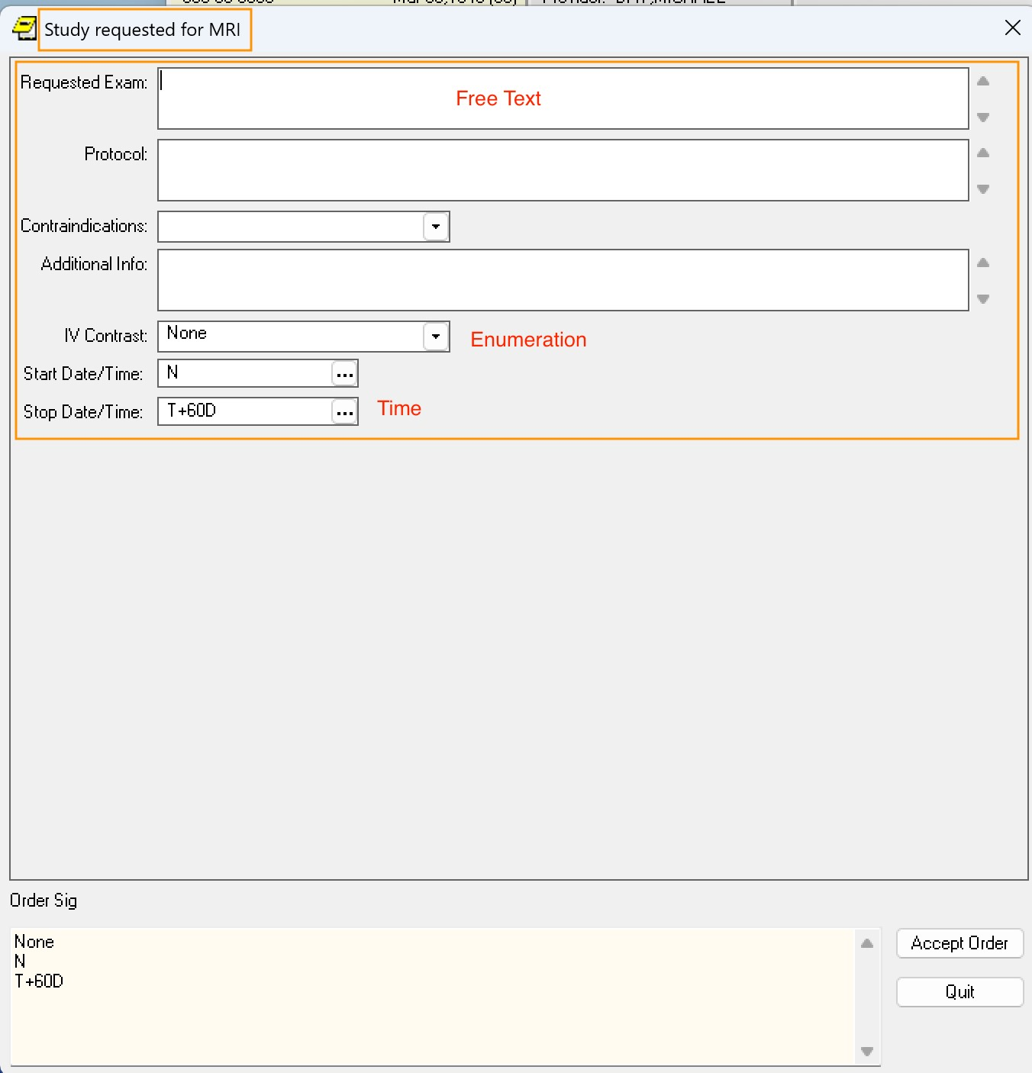

***Figure 3.2.1****: Generic Dialog for MRI Study.*



#### 3.2.2 Custom Order Dialogs

In contrast, Custom Order Dialogs are **tailored to particular classes of orders** such as medications, laboratory tests, radiology exams, and diet orders. These dialogs provide:

* **Custom layouts** tailored to the workflow of the order type
* **Complex prompts** specific to the order class (e.g., dosage and refills for medications, specimen type for labs, contrast for radiology)
* **Structured input controls** (drop-downs, radio buttons, checkboxes) that reduce error and standardize ordering

Custom dialogs are used for the **vast majority of clinical ordering** in CPRS.

The following example shows a Custom Dialog for creating an Infusion Order, with a tailored layout and a wide variety of prompts designed for this class of order:

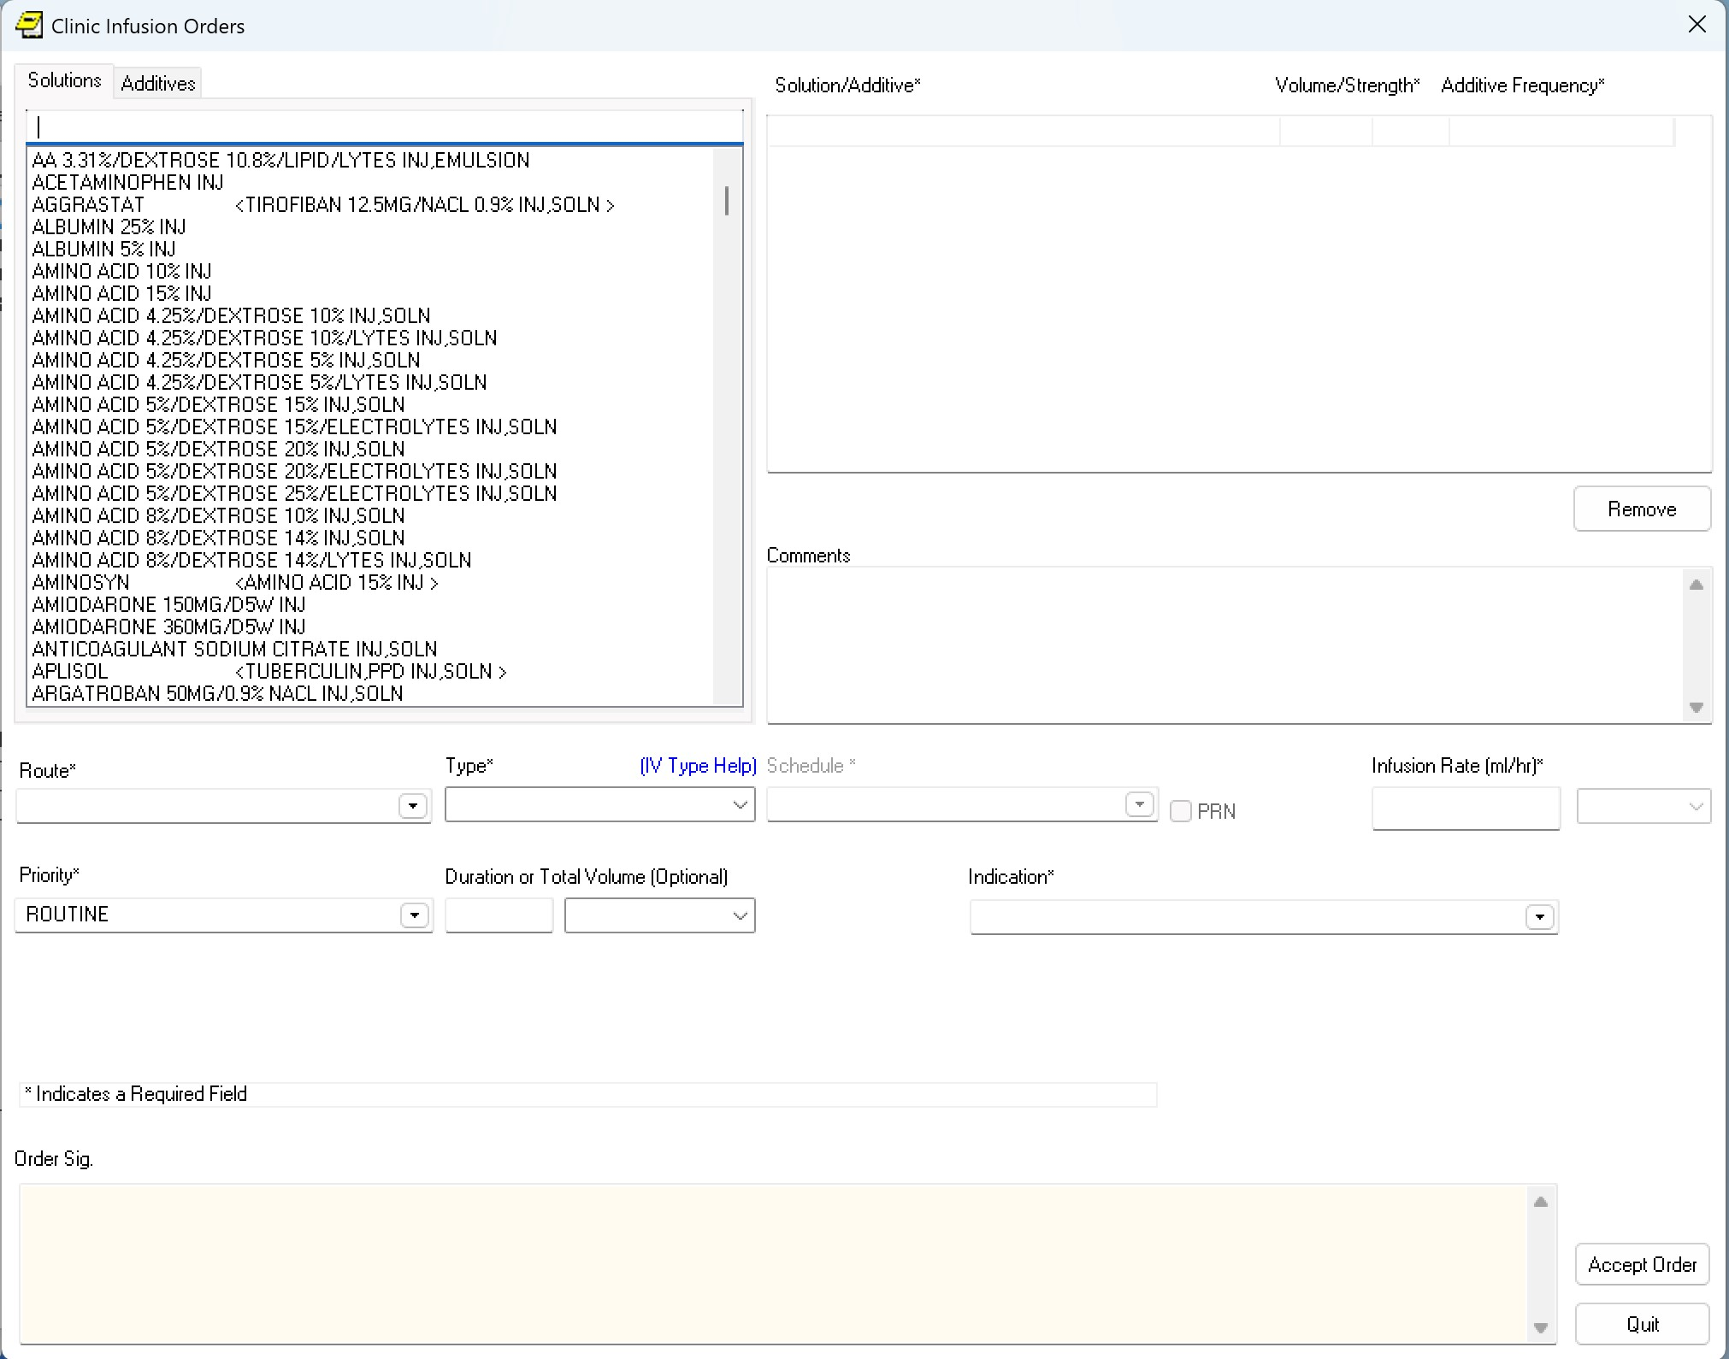

***Figure 3.2.2****: Custom Dialog for Infusion.*



⚖

**Summary**

:



The **Generic Order Dialog** illustrates the flexibility of VistA’s ordering subsystem but, due to its limitations, is used only for a small number of order types without custom support. The **Custom Order Dialogs**, tailored to specific classes of orders, guide clinicians through prompts that match each class’s clinical workflow and account for nearly all ordering activity in CPRS.

## 3.3 Navigating to Order

Quick and accurate ordering is determined by the balance between **navigation effort** and **prompt entry effort**. Like Quick Orders, **order navigation is site-specific and manually configured**—typically by Clinical Application Coordinators (CACs). The effectiveness of a site’s ordering depends not only on the quality of its Quick Orders but equally on the **quality of its navigation configuration**.

At one extreme, if the system offered a simple menu for explicit ordering, clinicians could quickly open the custom dialog for the order they want. However, they would then have to manually specify every prompt of that class—dosage, specimen, frequency, location, and so on—for each new entry. Such repeated prompt-filling is time-consuming.

At the other extreme, a VistA may lean heavily on Quick Orders, each pre-filling many of the prompts required for a specific type of order (e.g., *“BMP Panel, STAT”* or *“Flu Vaccine, Standard Dose”*). A typical VistA supports **thousands** of Quick Orders. Quick Orders save clinicians from repeatedly filling in the same details, but they introduce a new challenge: **navigation overhead**. How can CPRS allow a clinician to efficiently select from thousands of pre-defined Quick Orders?

This section examines how CPRS supports navigating to a desired order.



#### 3.3.1 Root Menus

In CPRS, order entry begins from a set of **Root Menus** displayed in the sidebar of the Orders tab. These menus are usually customized by **hospital location** or **clinician specialty**, so that the options most relevant to a ward, clinic, or role are presented to the ordering clinician.

A medical center may configure many or few Root Menus. Omaha VistA, for example, has over 1,500, while VCB maintains just 11. Too many root menus become difficult to manage, optimize, and clean up over time. Too few, on the other hand, fail to leverage this facility to present only the most relevant options for a given setting.

The following shows three example Root Menus displayed side by side:

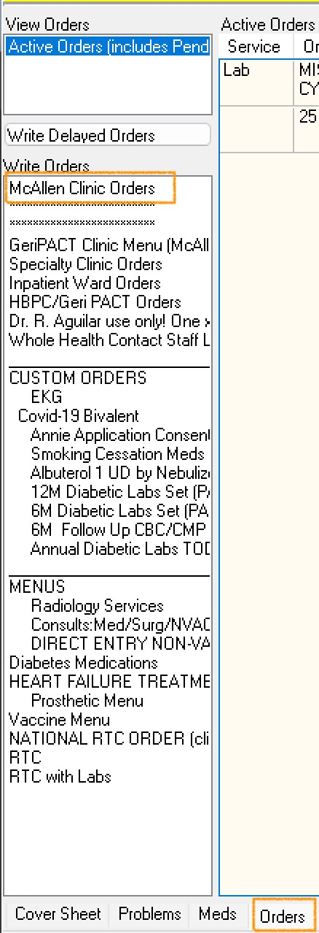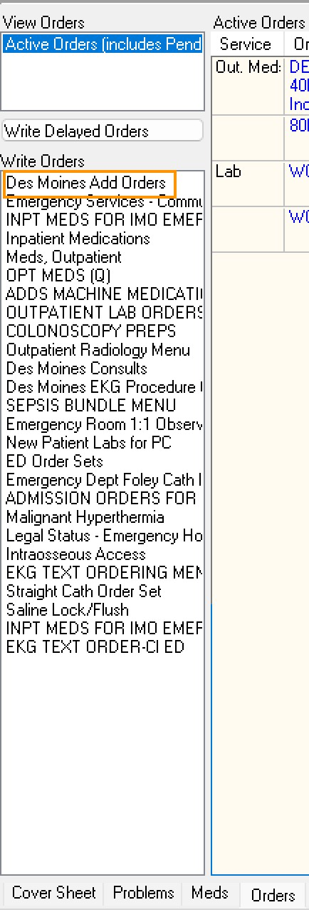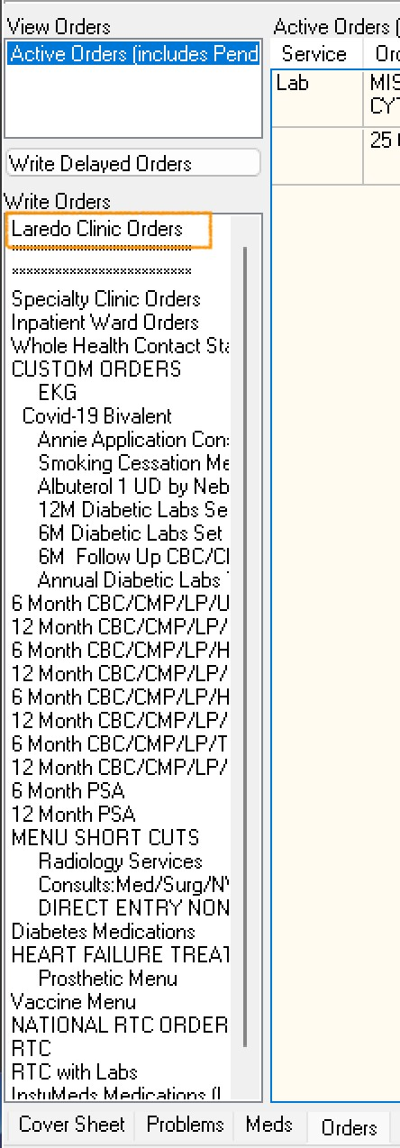

**Figure 3.3.1**: Three Root Menu Examples.



#### 3.3.2 Nested Menus

From the Root Menus, clinicians may occasionally launch an Explicit Order, but more often the Root Menu leads into the first level of **nested menus**. From there, clinicians navigate further to reach the Explicit Order or Quick Order they want to create. These nested menus organize options into logical groupings, often reflecting the categories of care in a particular setting.

Some nested menus become **“mega menus”**, gathering large numbers of Quick Orders of a particular type. For example, the menu below contains pre-filled medication orders, including a specific Quick Order for *mirtazapine*. The arrow symbol indicates a complete Quick Order where every prompt has been pre-filled.

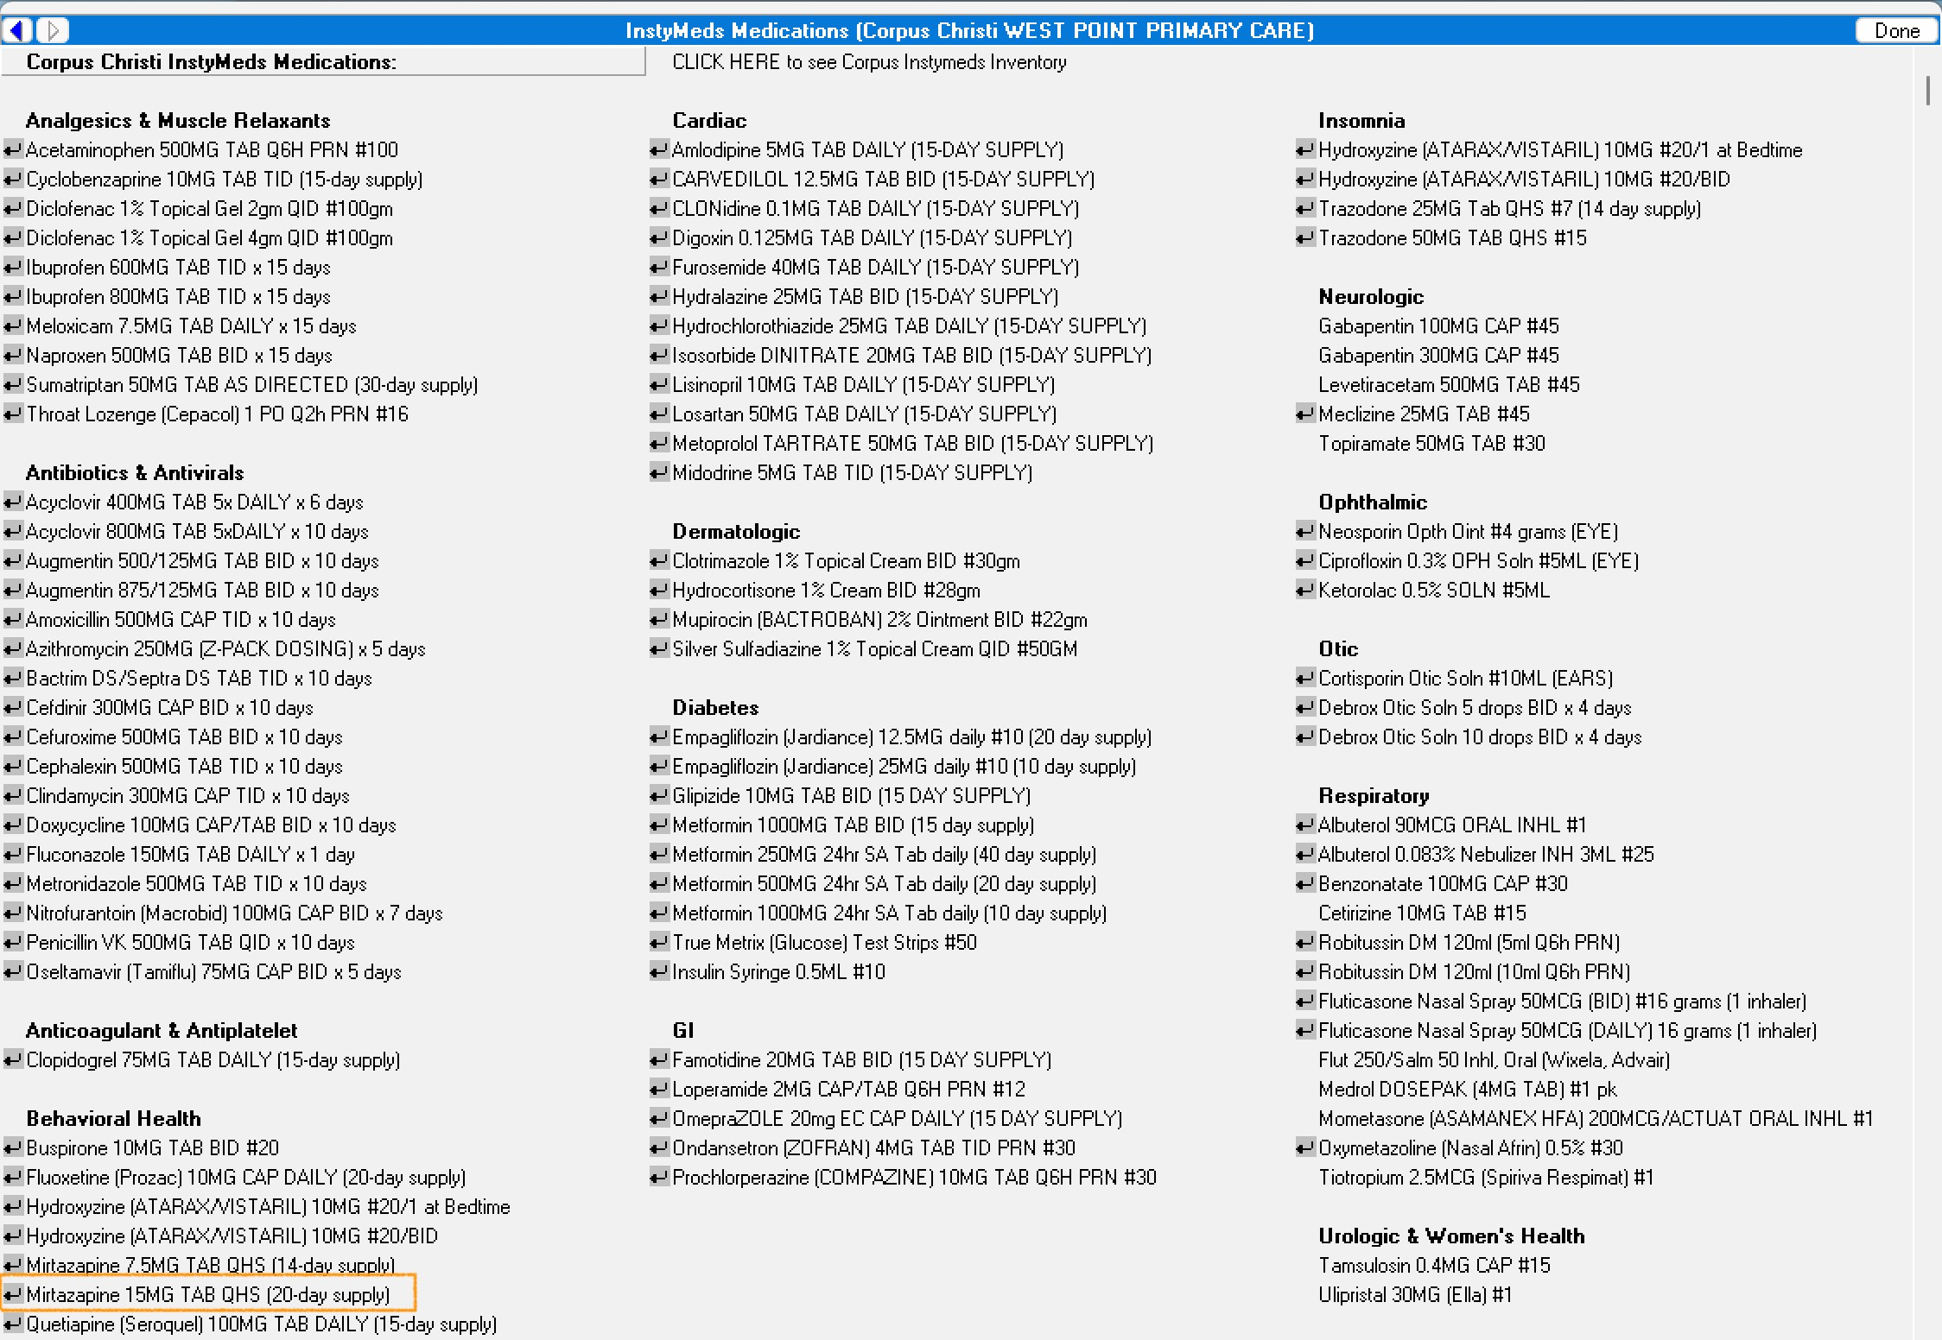

***Figure 3.3.2.1****: Nested “Mega Menu” for Quick Orders.*

Nested menus may also include guidance to direct the physician to the right option or even contact information to access support:

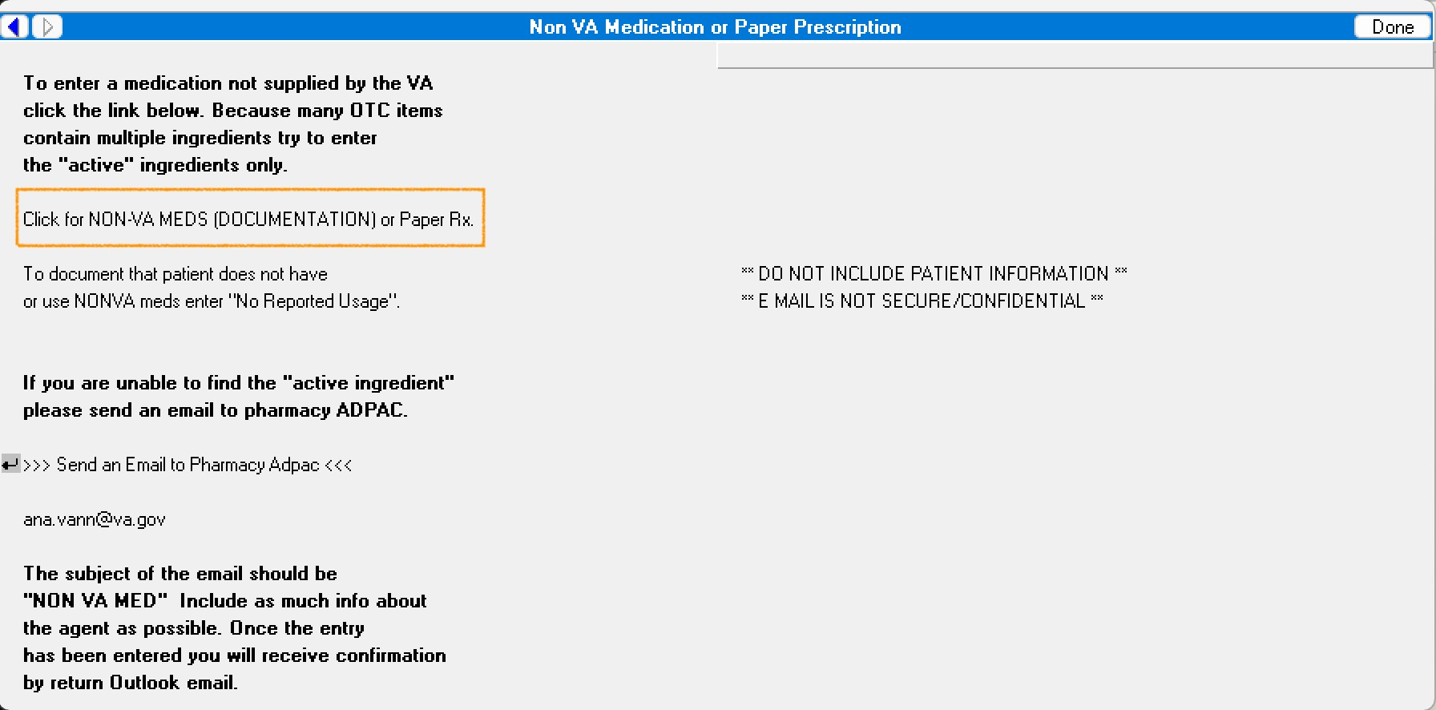

***Figure 3.3.2.2****: Nested Menu with Guidance.*

Some nested menus are too small to justify their own level. The example below contains only two options, leaving most of its space blank. It would have been clearer to add these directly to the parent menu:

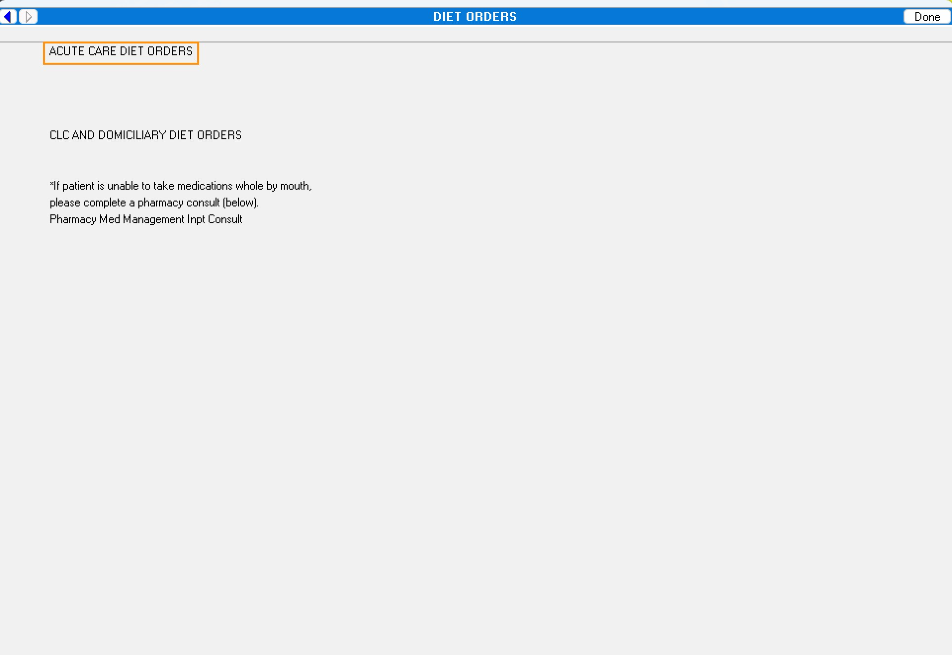

***Figure 3.3.2.3****: Nested Menu with too few options.*



#### 3.3.3 Buttons to Classes of Order

In addition to the Orders tab, the **Consults** and **Medications** tabs of CPRS provide direct access to their respective order classes.

The Consults tab includes two buttons, one for creating a **New Consult** order and another for a **New Procedure** order:

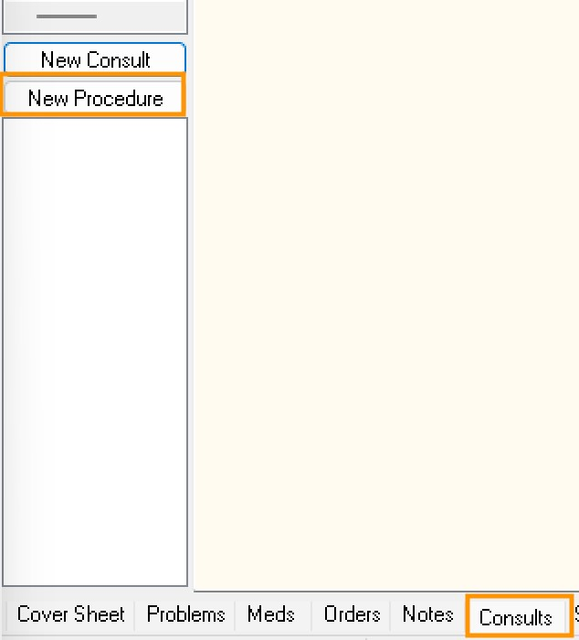

***Figure 3.3.3.1****: Buttons for New Consult or New Procedure Order.*

On the Medications tab, the Action menu offers an option to create a new medication order from scratch:

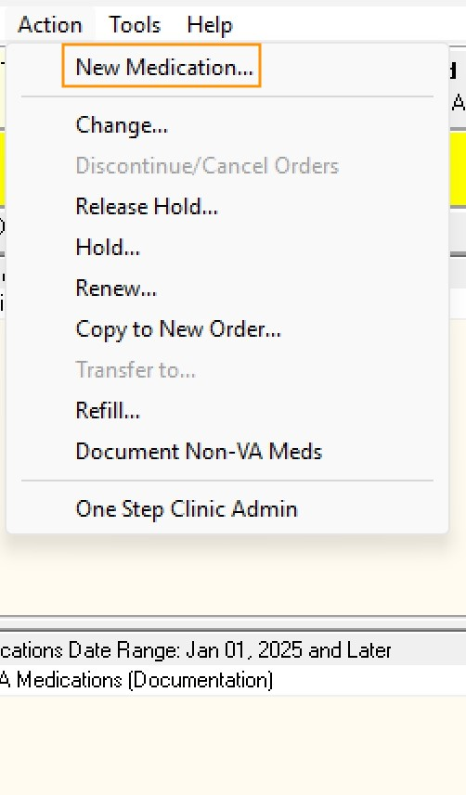

***Figure 3.3.3.2****: Option for New Medication Order.*

These direct-entry options are rarely used in practice. Nearly all ordering — including Consults and Medications — is initiated from the Orders tab.



#### 3.3.4 From Reminders to Orders

Some orders in VistA are created indirectly through **Reminder Dialog–backed templated notes**. While completing such a note, the clinician may choose to generate a Quick Order as part of the documentation process.



⚖ **Summary**:

Navigation is the key to efficient ordering in CPRS. The balance between **navigation effort** and **prompt entry effort** defines the clinician’s experience. Too few Quick Orders force repeated prompt-filling, while too many create menu overload. Root Menus, nested menus, and “mega menus” structure how clinicians find orders, but their design varies widely across sites and can either streamline or hinder access. Direct buttons on the Consults and Medications tabs provide shortcuts but are rarely used. In some cases, Reminder Dialog–backed notes generate orders as part of documentation. Ultimately, ordering efficiency depends not only on well-designed dialogs but also on the usability of the **manually configured navigation structures** that lead to them. In Section 5, we will argue for automating both navigation and Quick Order management to optimize order creation.

# 4. Empirical Analysis

## 4.1 Order Creation Examples

The examples below are drawn from VAA-captured traffic and reproduce **actual orders** from production VistAs. They illustrate the trade-off between **navigation length** and **prompt load** when creating orders.

Each workflow shows, in order, the **actual menus and dialogs** used by clinicians. The first example illustrates an **explicit order** where navigation is short and most effort involves filling prompts. The others show **Quick Orders** where navigation is longer but prompt entry is minimized.



#### 4.1.1 Explicit Order — Inpatient Medications (Omaha)

After selecting the **Orders** tab, the clinician saw the Root Menu assigned to their location/specialty and chose **Inpatient Orders**.

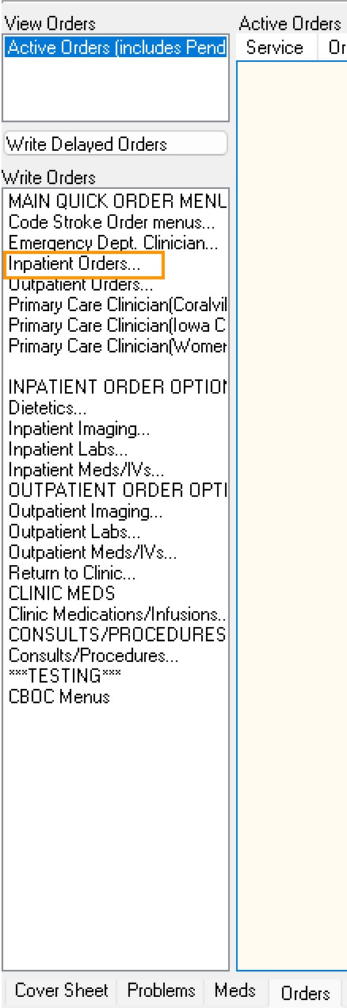

***Figure 4.1.1.1****: Root Menu — selecting “Inpatient Orders”.*

That choice opened the nested menu **INPT Medical Service** (note: an option name like “Inpatient Orders” need not match the launched menu title). From there, the clinician chose **Inpatient Medications**, which launched order entry.

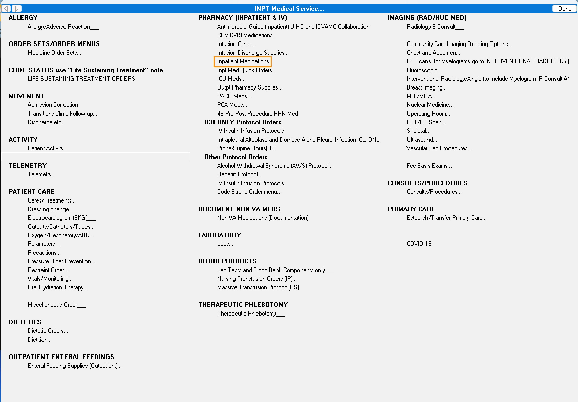

***Figure 4.1.1.2****: Nested menu “INPT Medical Service” — choosing “Inpatient Medications”.*

**Clicks to order entry (3):**

Orders (Root)

→ INPT Medical Service… (1)

→ Inpatient Medications (ACTION)

For order entry, a **search dialog** appeared to select the medication. The clinician searched for **Metoprolol**…

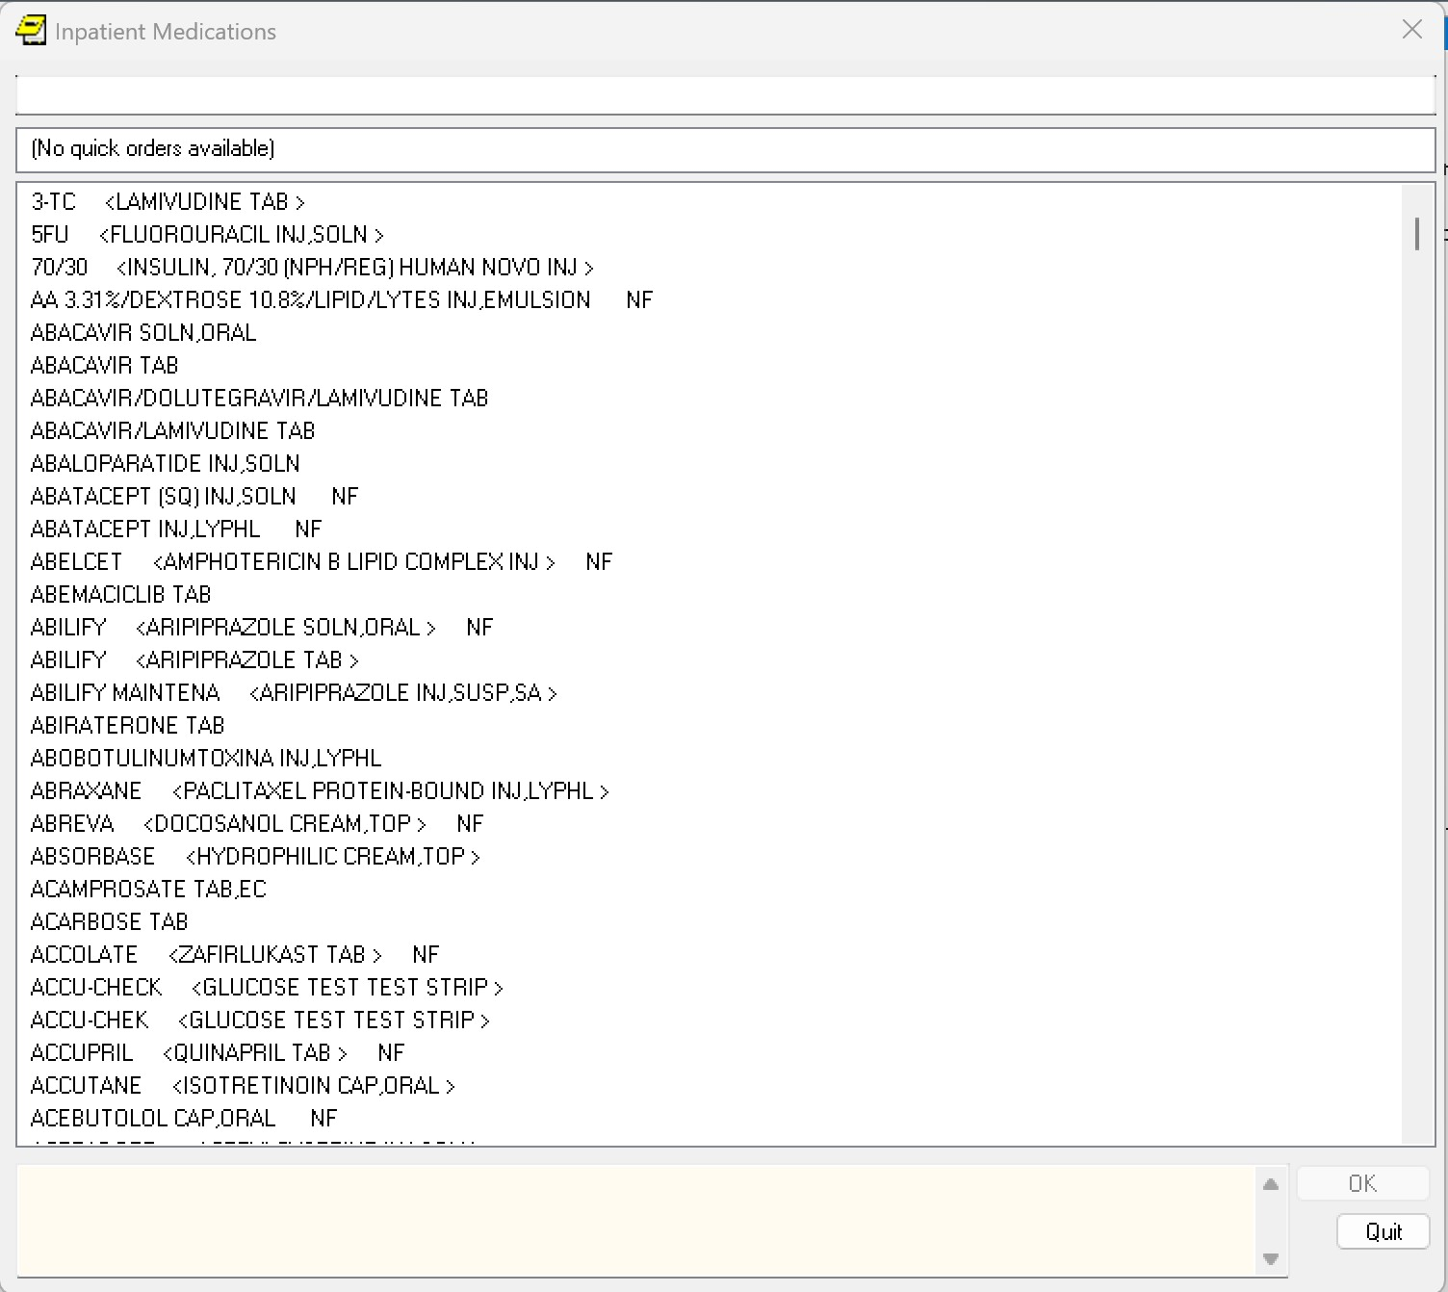

***Figure 4.1.1.3****: Medication search dialog — query for “Metoprolol”.*

After the clinician selected **Metoprolol Tablet**, CPRS opened the **Custom Order Dialog** for inpatient medications with the drug preselected; the remaining qualifying prompts still had to be completed.

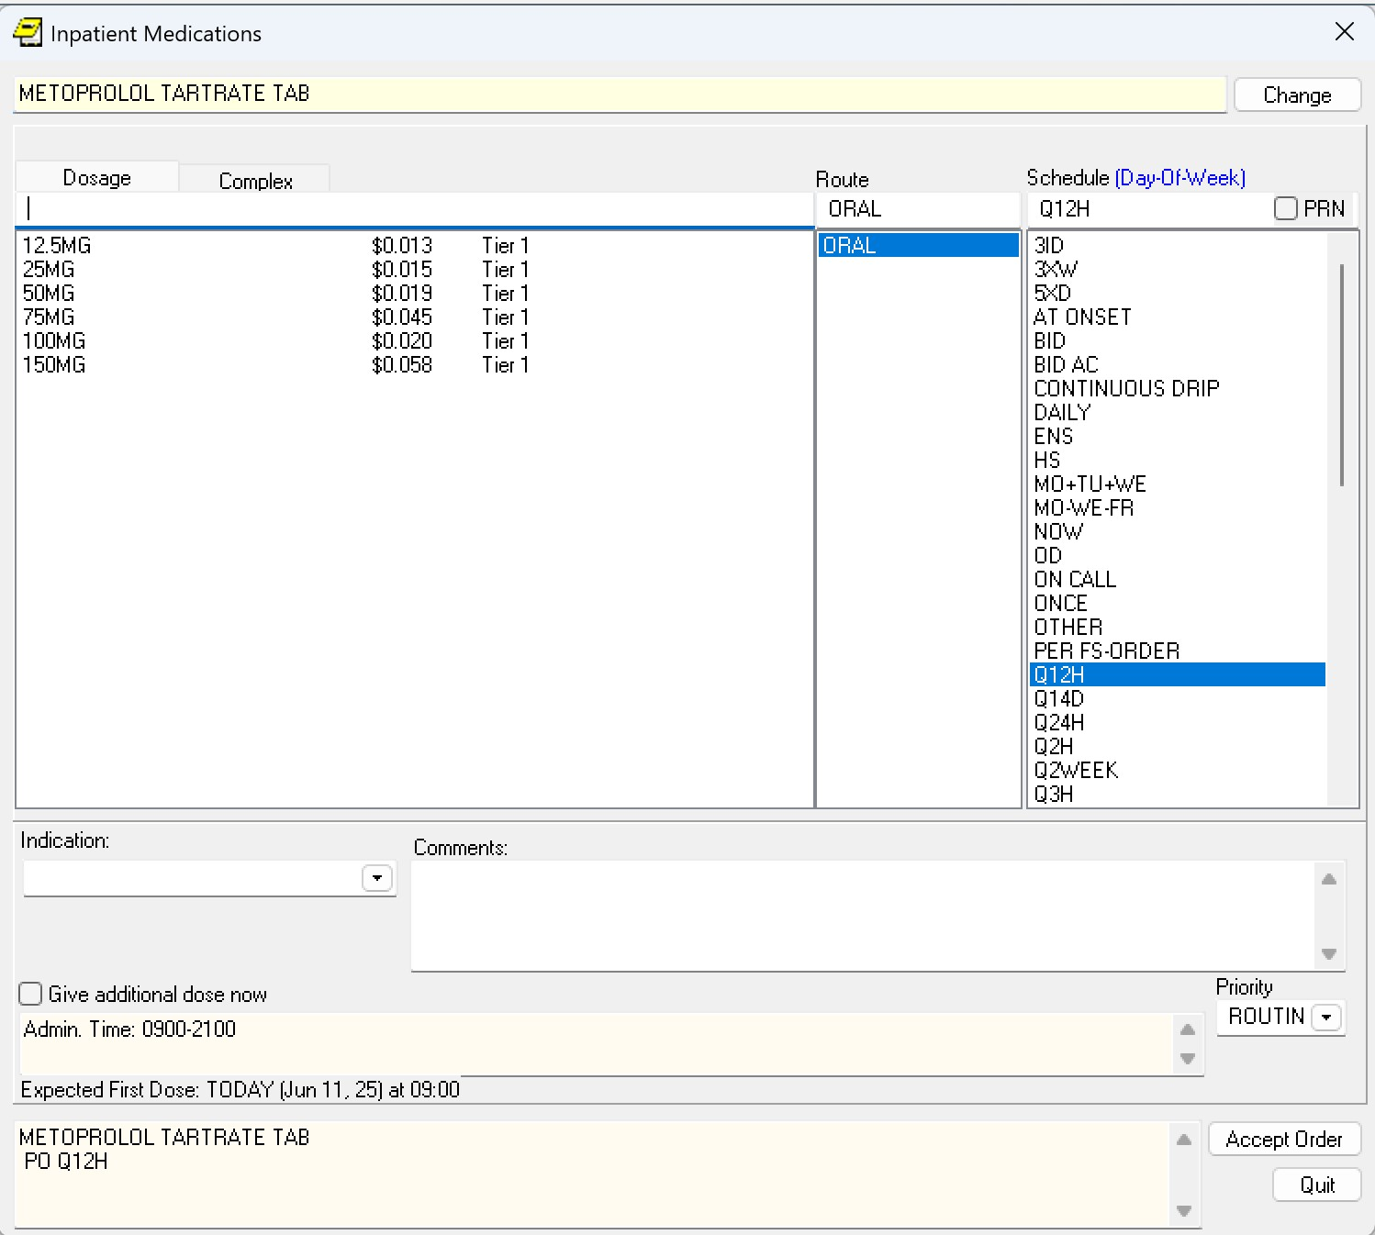

***Figure 4.1.1.4****: Inpatient Medication dialog — drug preselected; qualifiers unfilled.*

The clinician entered the **dosage** and **indication**, set **urgency** to STAT, and pressed **Accept** to send the order to VistA.

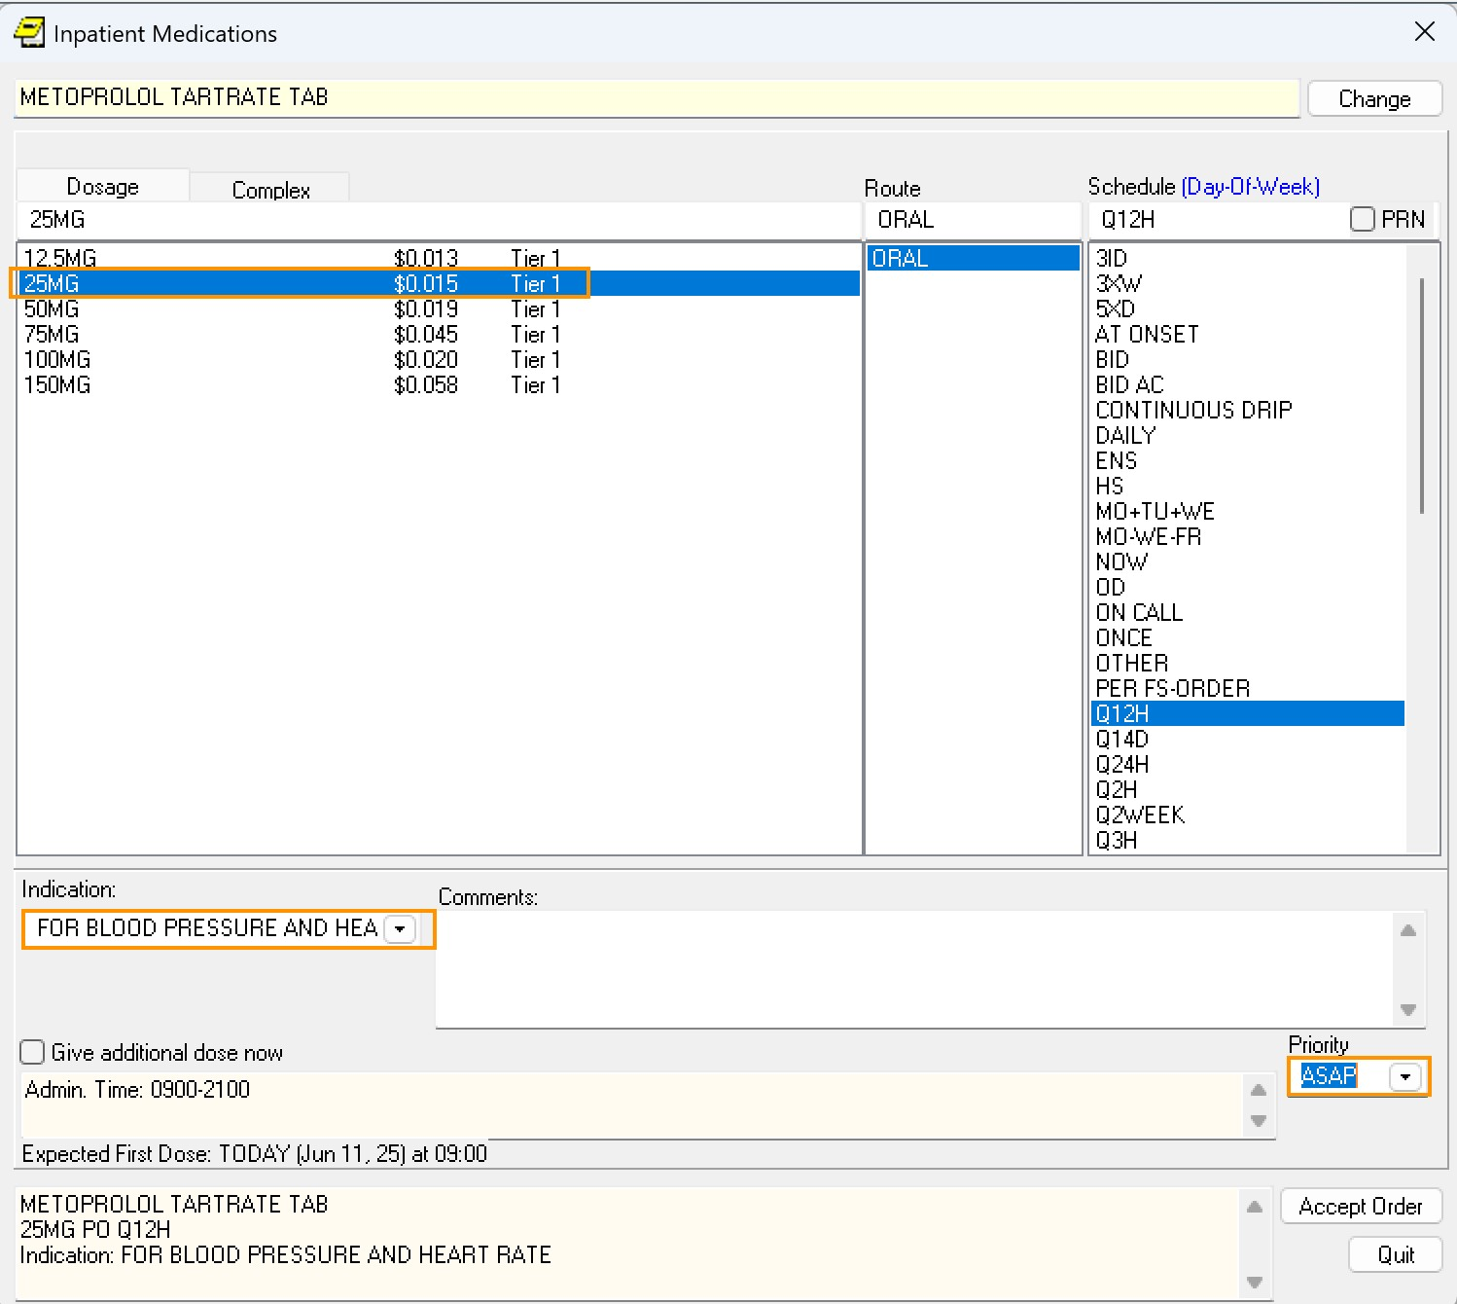

***Figure 4.1.1.5****: Inpatient Medication dialog — qualifiers completed prior to Accept.* **What we see**

* Short navigation; order entry begins quickly.
* High **prompt load**: search + all qualifying prompts.
* Most cognitive effort is in **completing prompts**.



#### 4.1.2 Quick Order — IV Fluids (Omaha)

After selecting the **Orders** tab, the clinician saw the Root Menu assigned to their location/specialty and selected **Emergency Dept. Clinician** from it.

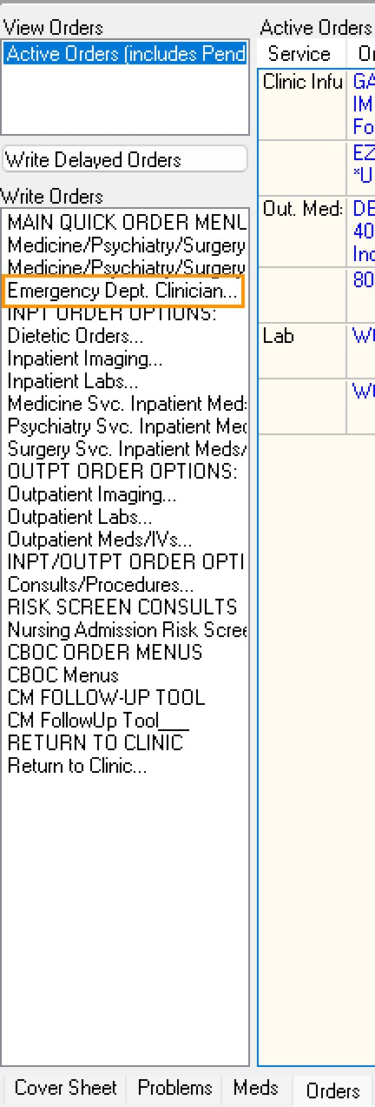

***Figure 4.1.2.1****: Root Menu — selecting “Emergency Dept. Clinician”.*

The nested menu of the same name appeared; the clinician chose **IV Fluid Quick Orders**…

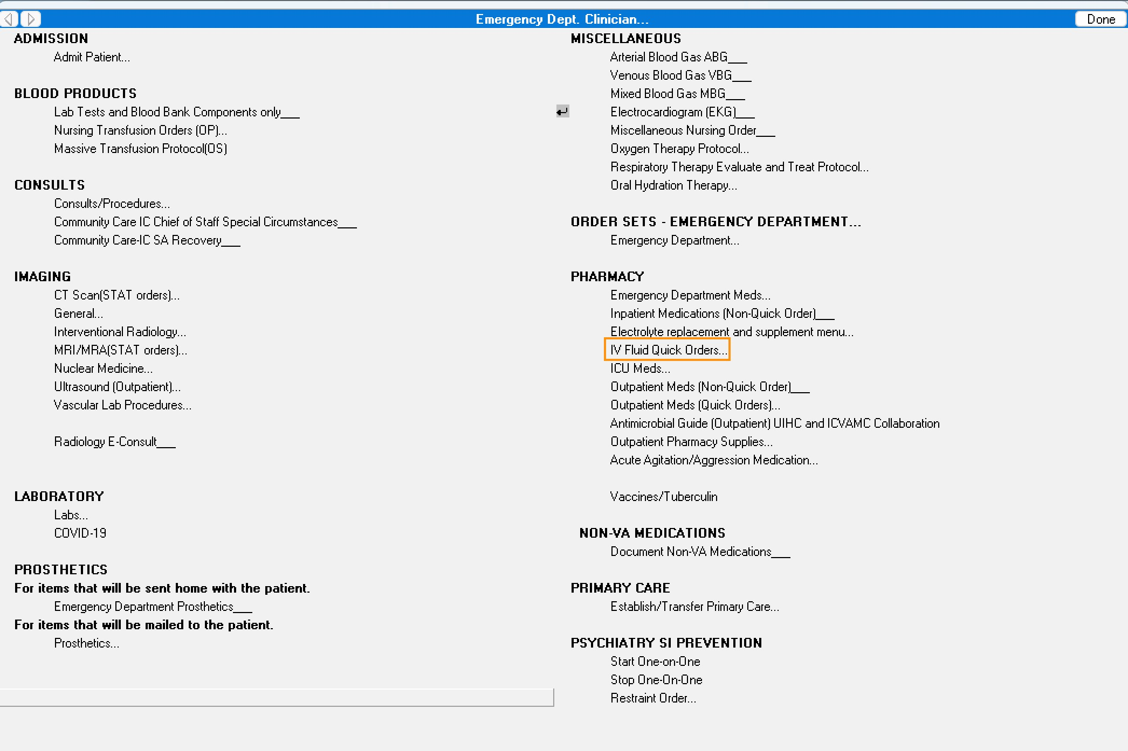

***Figure 4.1.2.2****: Nested menu — choosing “IV Fluid Quick Orders”.*

A nested “mega menu” appeared with precise IV options; the clinician selected **NaCl 0.9% (Normal Saline)**.

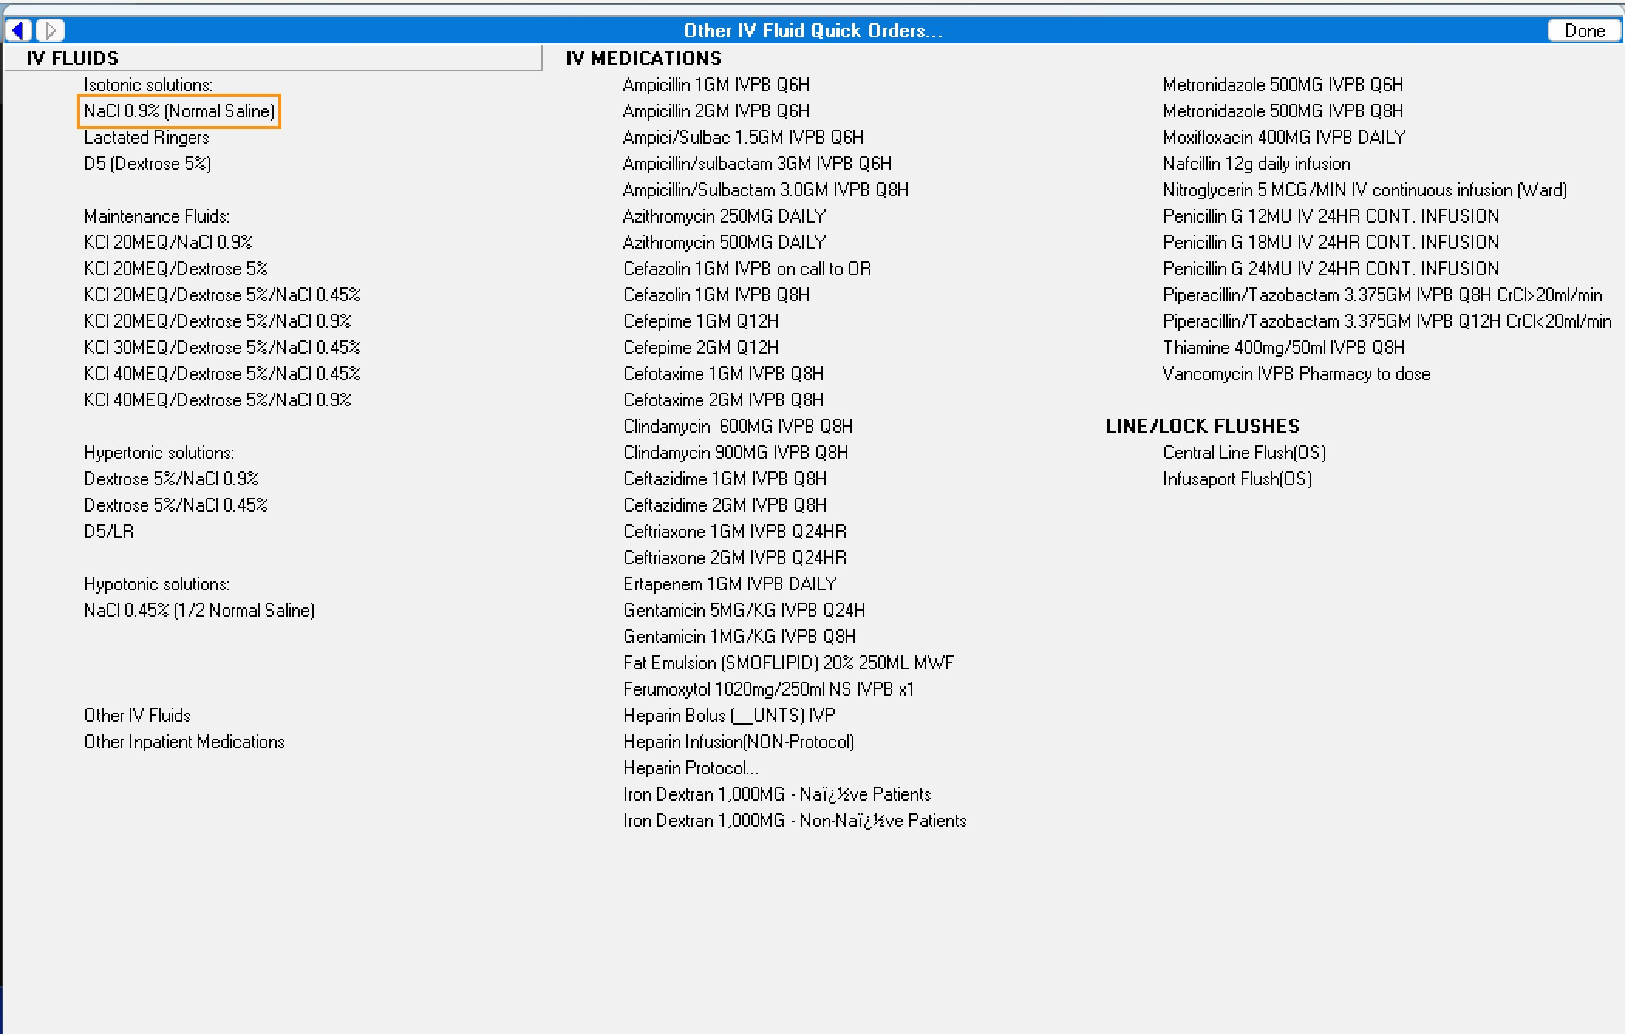

***Figure 4.1.2.3****: IV fluids “mega menu” — selecting “NaCl 0.9% (Normal Saline)”.*

**Clicks to order entry (4):**

Orders (Root)

→ Emergency Dept. Clinician… (1)

→ IV Fluid Quick Orders… [TITLE: Other IV Fluid Quick Orders…] (2)

→ NaCl 0.9% (Normal Saline) (ACTION)

The **Clinic Infusion Orders** dialog opened with the **solution/additive preselected** by the

Quick Order. (This dialog also supports searching when launched without a preselection.)

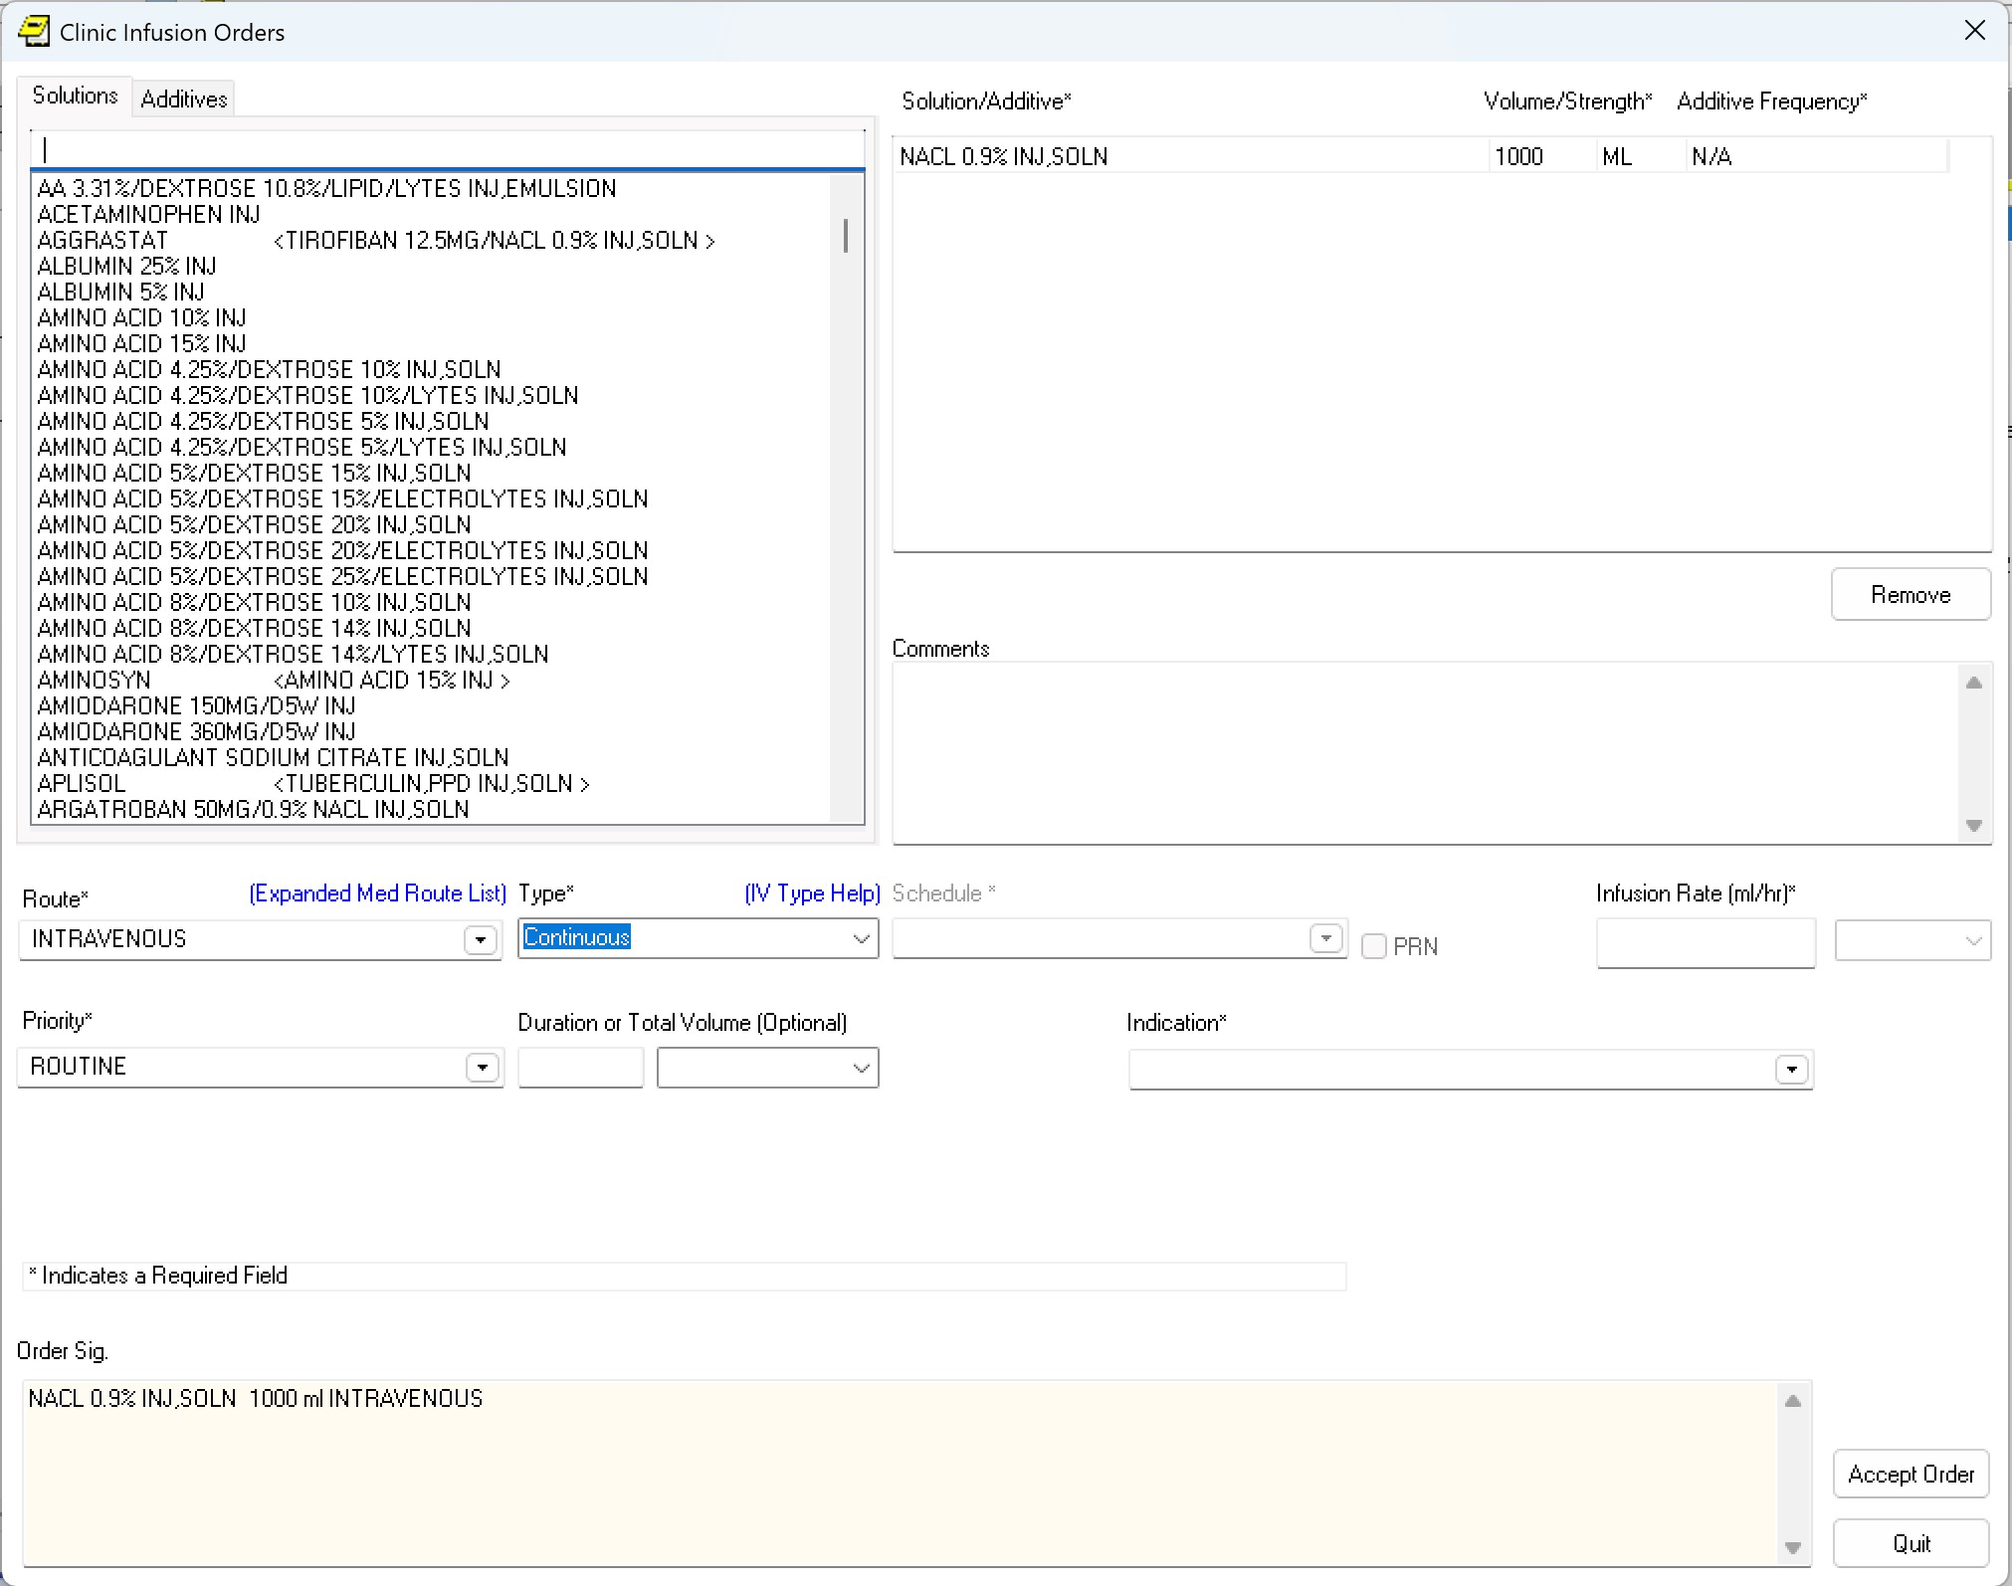

***Figure 4.1.2.4****: Clinic Infusion dialog — solution/additive preselected by Quick Order.*

The Quick Order also **pre-filled the volume**; the clinician **adjusted** that default.

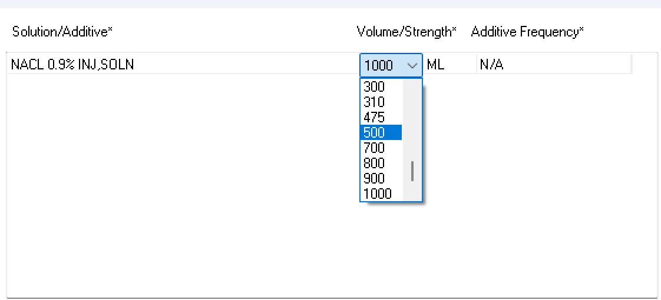

***Figure 4.1.2.5****: Volume preset from Quick Order — clinician adjusts default.*

Including the volume change, the clinician made **four small edits** before **Accept**.

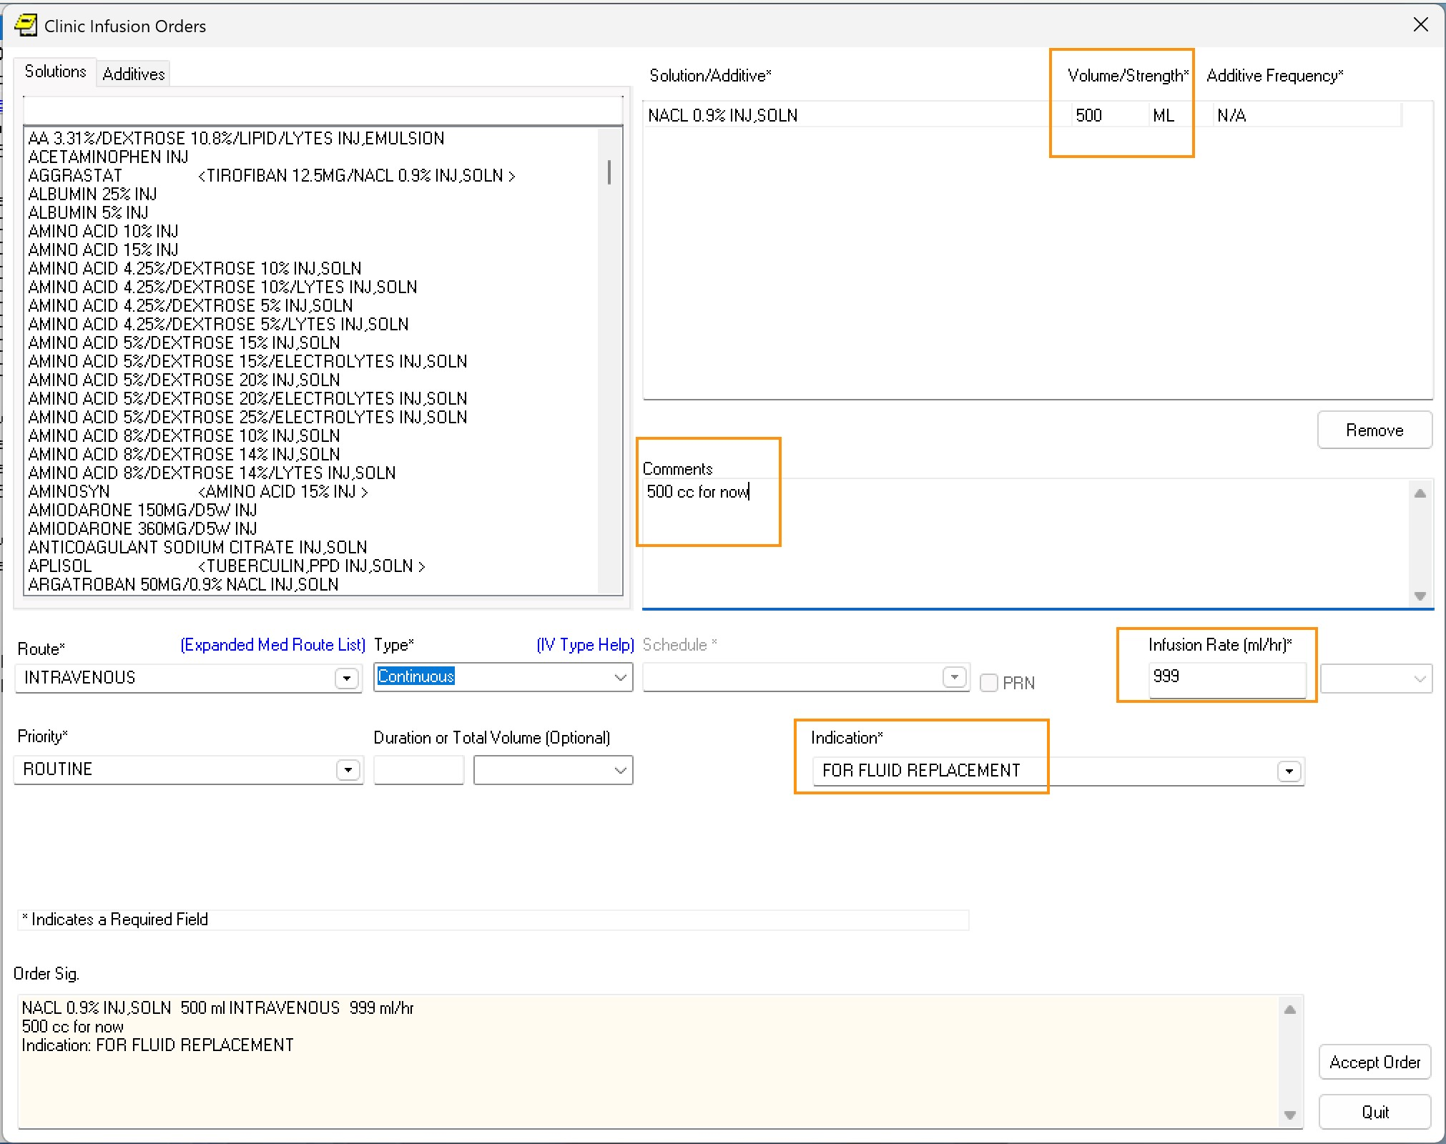

***Figure 4.1.2.6****: Finalized infusion order — minor edits prior to Accept.* **What we see**

* With the drug/solution **pre-selected**, the clinician avoids searching within the dialog.
* **Prompt load** is small (tweaks to defaults).
* **Cognitive effort shifts to navigation** (finding the right Quick Order).



#### 4.1.3 Quick Order — Imaging (VCB)

After selecting the **Orders** tab, the clinician viewed the Root Menu and selected **Corpus Christi (Primary Care/Behavioral)** from it.

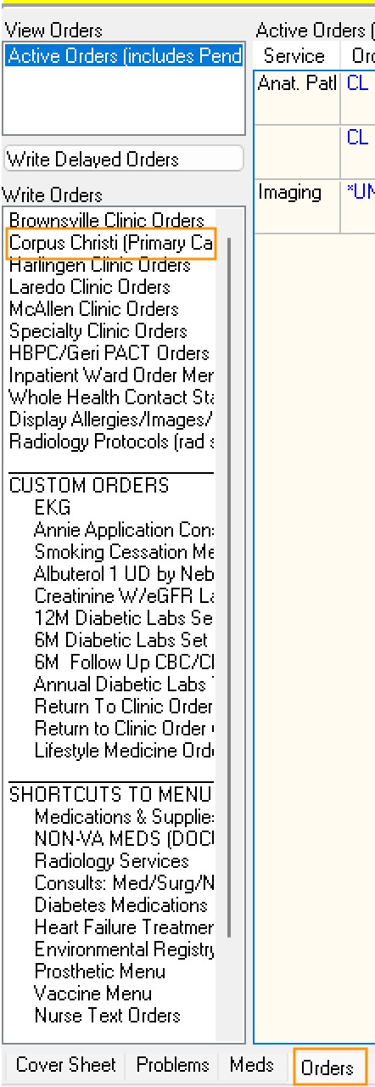

***Figure 4.1.3.1****: Root Menu — selecting “Corpus Christi (Primary Care/Behavioral)”.*

Under Radiology Services, **Mammography Screenings** was selected…

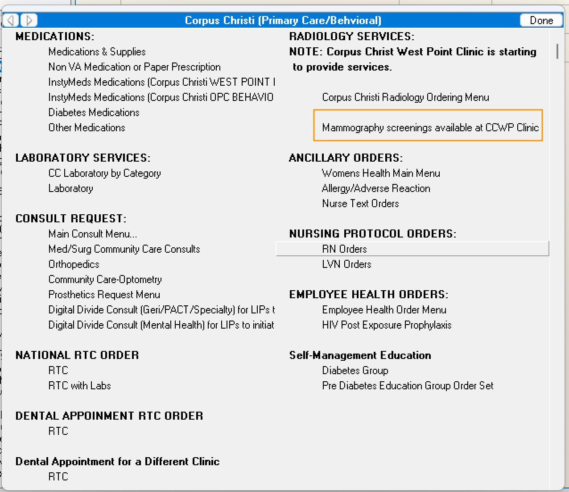

***Figure 4.1.3.2****: Nested menu — selecting “Mammography Screenings”.*

Despite the **Community Care Mammography** label, the menu steers toward in-house options; the clinician picked the first.

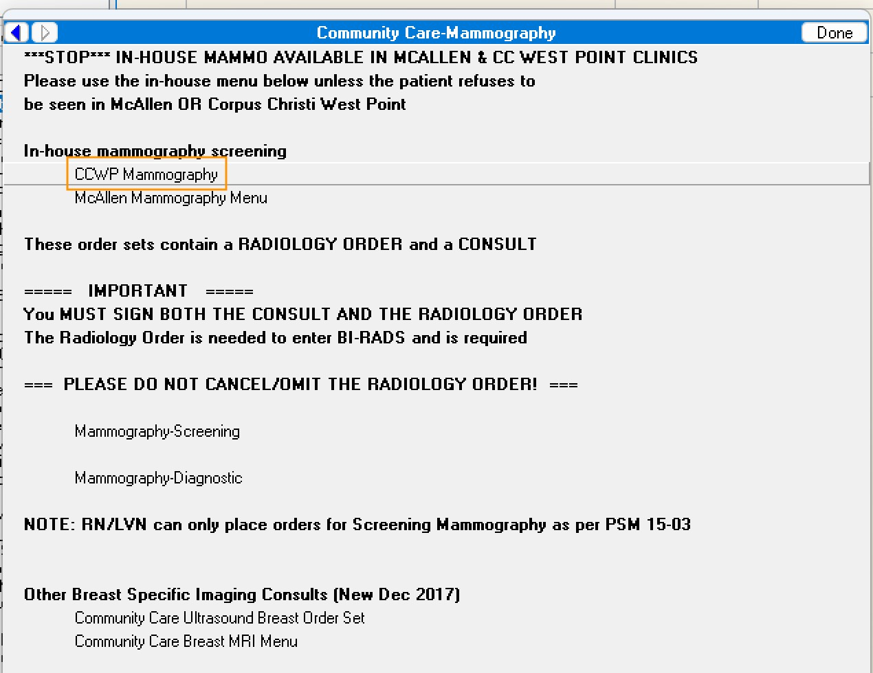

***Figure 4.1.3.3****: Nested menu — Community Care Mammography options.*

The next menu offered a **single relevant option** (question: why wasn’t this surfaced one level earlier?).

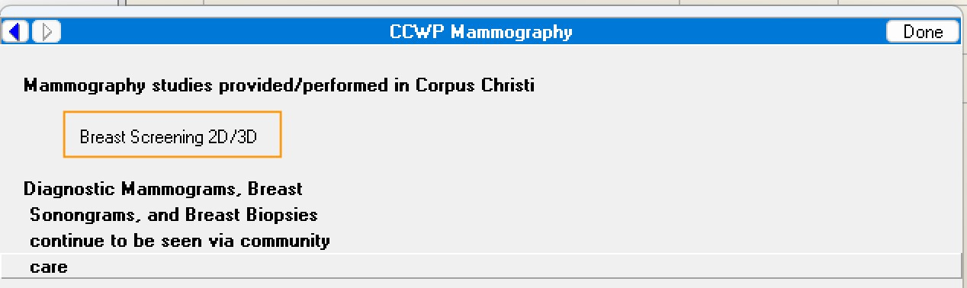

***Figure 4.1.3.4****: Nested menu — single-option screen (CCWP Mammography).*

**Clicks to order entry (5):**

Orders (Root)

→ Corpus Christi (Primary Care/Behavioral) [15831] (1)

→ Community Care – Mammography [18862] (2)

→ CCWP Mammography [24979] (3)

→ Breast Screening 2D/3D [24980] (ACTION)

In the **Imaging Order Dialog**, the Quick Order **pre-selected** the **study type** (“Mammography”), the **procedure** (“Breast Screening …”), and the **location** (“CCWP MAMMO”). The clinician then set the **date** and **reason**.

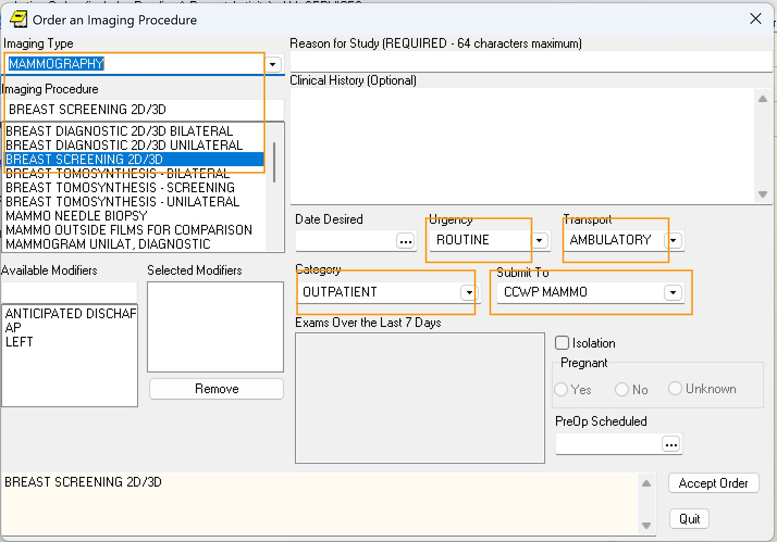

***Figure 4.1.3.5****: Imaging Order Dialog — study/procedure/location preset; date+reason entered.*

**What we see**

* The Quick Order pre-sets the **study type** and **specific procedure**, eliminating the need to search for either within the dialog.
* Remaining prompts are minimal (date, reason).
* One menu level appears **unnecessarily shallow** (only one option).



#### 4.1.4 Quick Order — Busy “Mega Menu” (VCB)

From the same Root Menu used in the imaging example above, the clinician again selected **Corpus Christi (Primary Care/Behavioral)**.

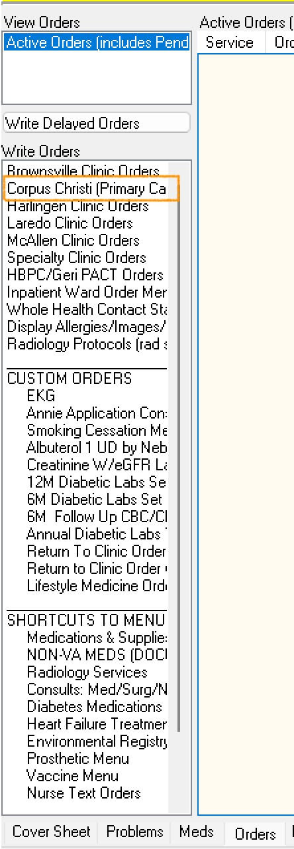

***Figure 4.1.4.1****: Root Menu — selecting “Corpus Christi (Primary Care/Behavioral)”.*

This time, under the **Medications** heading, the clinician selected **InstyMeds Medications**, a large set of Quick Orders that fully specify medication orders.

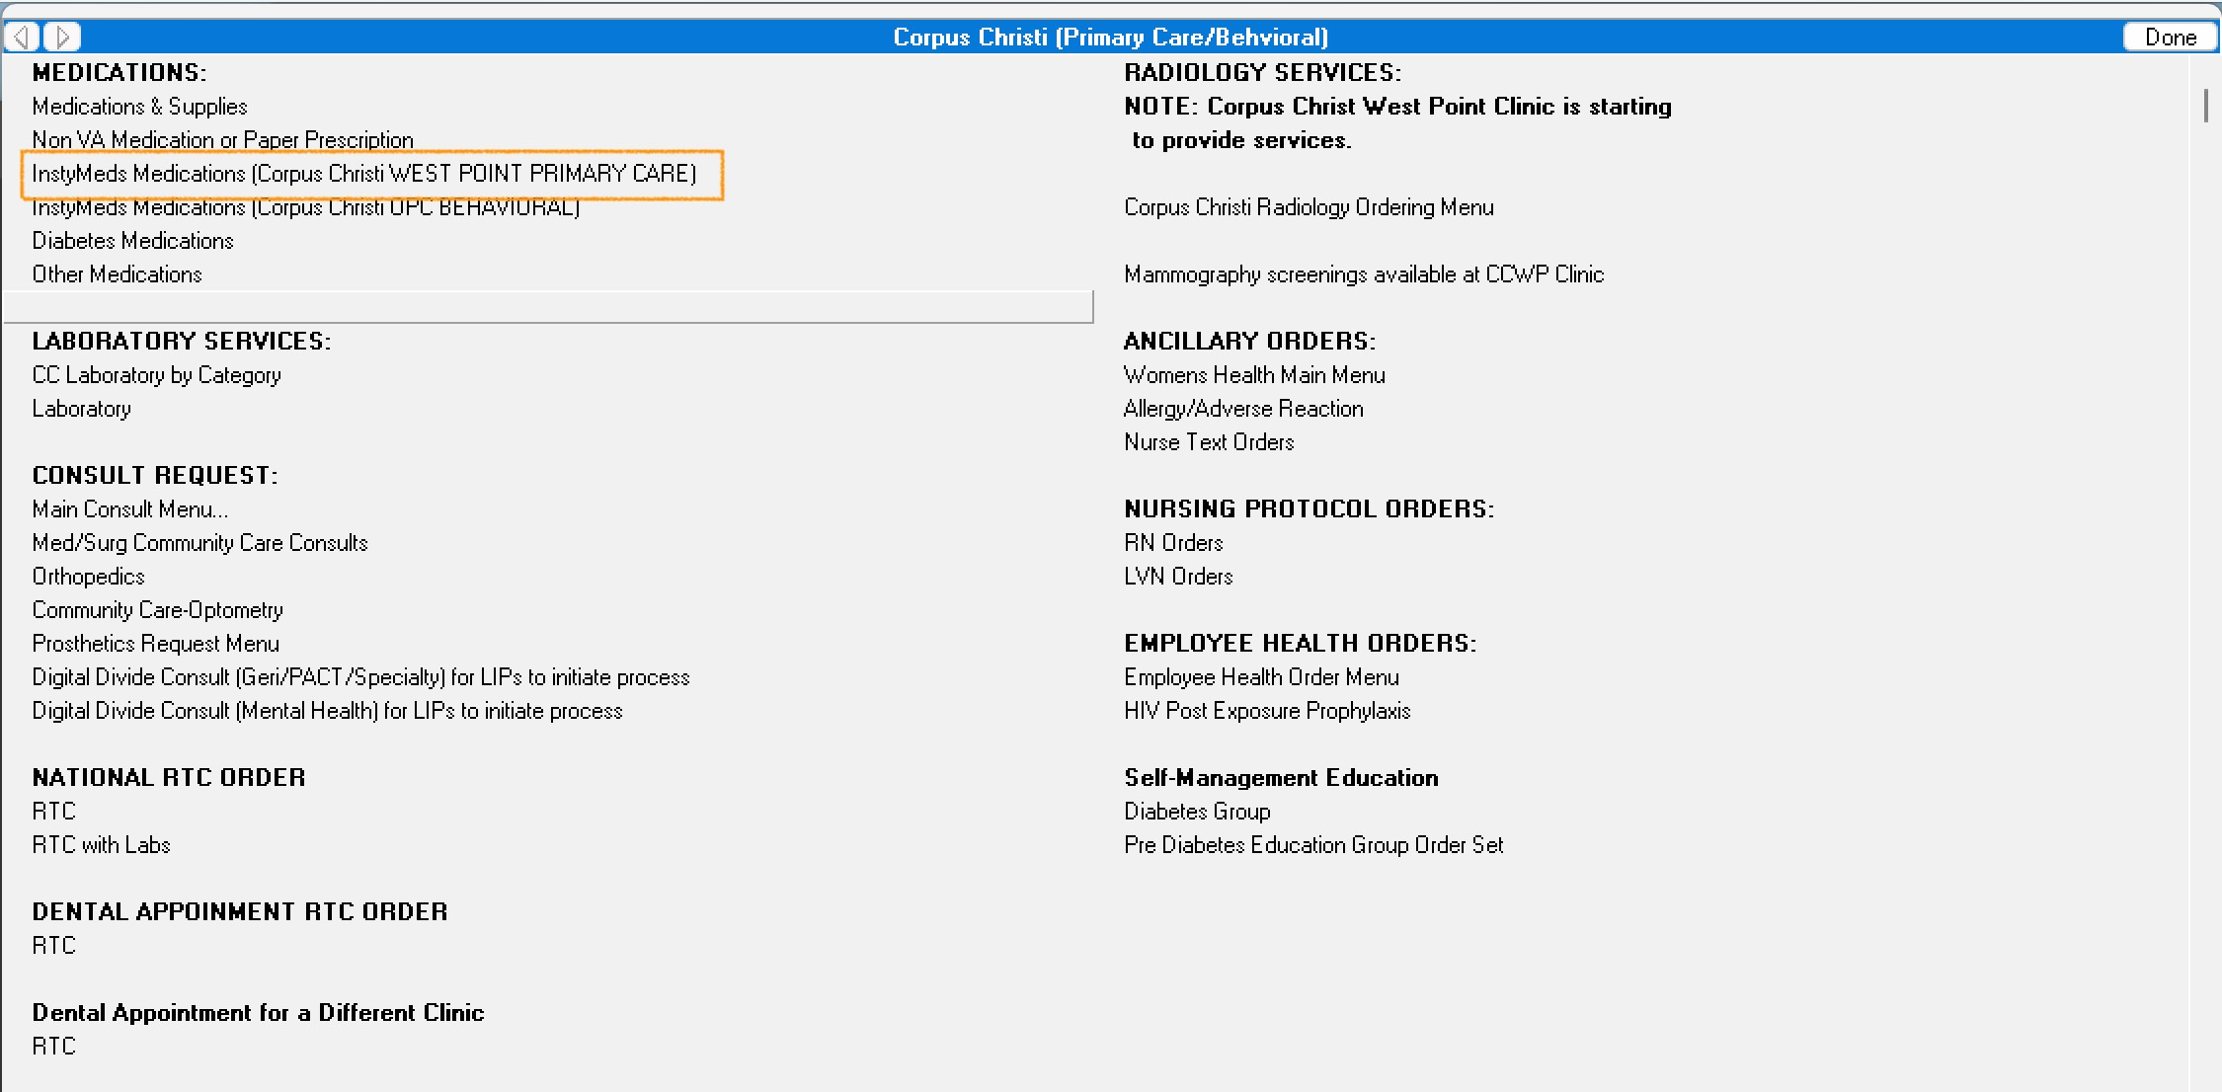

***Figure 4.1.4.2****: Nested menu — “InstyMeds Medications” category.*

**InstyMeds** is a **mega menu** (note the tiny scrollbar), listing many fully specified choices. The clinician selected **Mirtazapine 15 mg TAB QHS (20-day supply)**. Since the order is fully specified, selecting the Quick Order places it immediately—**no dialog appears**.



***Figure 4.1.4.3****: InstyMeds mega menu — choosing a fully specified medication Quick Order.*

**Clicks to order (4):**

Orders (Root)

→ Corpus Christi (Primary Care/Behavioral) [15831] (1)

→ InstyMeds Medications (Corpus Christi WEST POINT PRIMARY CARE) [22975] (2)

→ Mirtazapine 15 MG TAB QHS (20-day supply) [25979] (ACTION)

**What we see**

* **No dialog**: choosing the Quick Order immediately places the order.
* Shifts cognitive effort to **visual search/recognition** in a very large list.
* **Only efficient for frequently used options:** repetition builds spatial/label memory, letting clinicians scan directly to the choice; otherwise the visual search cost remains high.



### Summary

Across these examples, ordering speed depends on where the effort lands:

* **Explicit Orders:** short navigation, high prompt load (search + complete all qualifiers).
* **Quick Orders (typical):** longer navigation, low prompt load (minor tweaks to defaults).
* **Quick Orders (mega menus):** longest navigation/visual search, no prompt load (instant order).

**Design implications** - Keep **navigation depth** proportional to usage—avoid one- or twoitem submenus and overly broad mega menus. - **Promote/pin** high-use Quick Orders; **prune** rarely used ones. - Where explicit orders dominate, add **targeted Quick Orders** to reduce prompt burden. - Where mega menus dominate, **split** or **smart-filter** to cut search time.

**Net effect:** balance **navigation effort** and **prompt entry effort** to minimize time-to-order and reduce errors.

## 4.2 Order Class Metrics

This section summarizes orders observed in VAA’s sampled traffic from the VCB and Omaha VistAs. **VCB** is an outpatient-only medical center; **Omaha**, which also provides inpatient care, shows a broader mix of order classes.



#### 4.2.1 VCB

In the sample, **10 Specialized Order Classes** accounted for **65,330** orders: some only as **explicit** orders (e.g., *Meds, Non-VA*), a few only as **Quick Orders** (e.g., *Supplies*), and the remainder in both forms. Traffic analysis shows support for **1,701** distinct Quick Order types.

Quick Order Quick

# Name Explicit Orders Types Orders

|  |  |  |  |  |
| --- | --- | --- | --- | --- |
| 1 | **Laboratory** | 6,214 | 386 | 19,916 |
| 2 | **Return To Clinic** | 13,641 | 19 | 279 |
| 3 | **Consult** | 2 | 435 | 13,032 |
| 4 | **Outpatient Medications** | 5,726 | 549 | 2,393 |
| 5 | **Imaging** | 121 | 280 | 2,592 |
| 6 | **Meds, Non-VA (Documentation)** | 831 |  |  |
| 7 | **General Purpose Generic Order** |  | 18 | 362 |
| 8 | **Procedure** | 144 |  |  |
| 9 | **Supplies** |  | 13 | 72 |

Quick Order Quick

# Name Explicit Orders Types Orders

1 **Inpatient Medications** 1 5

0

**Notes** - Consult orders were **overwhelmingly** placed via **Quick Orders**; *Procedures*—also orderable from the Consults tab—were **always explicit**. - *Return to Clinic* (appointment) orders were largely **explicit**. - *Laboratory* and *Outpatient Medications* showed a **mixed** pattern (explicit + Quick Orders). - VCB is **outpatient-only**. The small *Inpatient Medications* count reflects use of that dialog in outpatient contexts, **not** inpatient care.

In addition to the Specialized Order Classes, there were **1,061 orders** placed using the **base generic** ordering subsystem and its basic CPRS dialog.



#### 4.2.2 Omaha

In the same sample, Omaha clinicians used **20 Specialized Order Classes** to create **48,710 orders**. Captured traffic indicates the system supports **5,017** Quick Order types.

Because Omaha provides inpatient care, its traffic includes Order Classes absent at VCB—Inpatient/Clinic Medications, Infusion, and diet orders (e.g., Tube Feeding, Early/Late Tray).

Quick Order Quick

# Name Explicit Orders Types Orders

|  |  |  |  |  |
| --- | --- | --- | --- | --- |
| 1 | **Laboratory** | 2,873 | 1,824 | 14,970 |
| 2 | **Return To Clinic** | 8,644 | 5 | 52 |
| 3 | **Consult** | 85 | 1,152 | 7,135 |
| 4 | **Outpatient Medications** | 4,232 | 542 | 1,372 |
| 5 | **Inpatient Medications** | 2,692 | 365 | 1,142 |
| 6 | **Imaging** | 30 | 634 | 1,697 |
| 7 | **Clinic Medications** | 376 | 228 | 1,084 |
| 8 | **Meds, Non-VA (Documentation)** | 776 | 5 | 5 |
| 9 | **Procedure** |  | 63 | 545 |
| 1  0 | **Diet Orders** | 38 | 51 | 310 |
| 1  1 | **Clinic Infusions** | 34 | 51 | 183 |
| 1 | **Infusion** | 46 | 55 | 122 |

2

Quick Order Quick

# Name Explicit Orders Types Orders

|  |  |  |  |
| --- | --- | --- | --- |
| 1 **Supplies**  3 | 36 | 26 | 87 |
| 1 **Blood Products**  4 | 2 | 9 | 58 |
| 1 **Vital Signs**  5 | 3 | 4 | 52 |
| 1 **Tubefeeding**  6 | 14 |  |  |
| 1 **Additional Orders**  7 | 7 |  |  |
| 1 **General Purpose Generic Order**  8 |  | 2 | 4 |
| 1 **Early/Late Tray**  9 | 3 |  |  |
| 2 **Isolation/Precautions** |  | 1 | 1 |

0

In addition to the Specialized Order Classes, there were **5,115 orders** placed using the **base generic** ordering subsystem and its CPRS dialog.



### 4.2 Summary

* **Consult** and **Laboratory** classes lean heavily on **Quick Orders** at both sites.
* **Return to Clinic** orders skew **explicit**.
* **Outpatient Medications** and **Inpatient Medications** show a **mixed** pattern (Explicit + Quick Orders).
* Omaha’s inpatient capability expands the range of order classes in use (**Inpatient/Clinic Medications, Infusions, Diet Orders** …).

Implication: menu design and Quick Order curation should reflect **site scope** (outpatient vs. inpatient) and **actual usage** within each order class.

## 4.3 Menu Metrics

We analyzed six weeks of VAA traffic for Valley Coastal Bend (VCB). The recommendations below assume this window is sufficient to identify which menus, Order Sets, and dialogs clinicians actually use—and which, though presented, are rarely or never invoked.



#### 4.3.1 Menus

VCB traffic shows **21 Root Menus** and **715** nested menus. Of the 715, **7** appeared only inside Order Sets; the remaining **708** were reachable from Root or other nested menus. Of these 708, **504 (71.2%)** were chosen at least once; **204 (28.8%)** were presented but never chosen—prime candidates for removal.

**How often the 504 chosen nested menus were selected:**

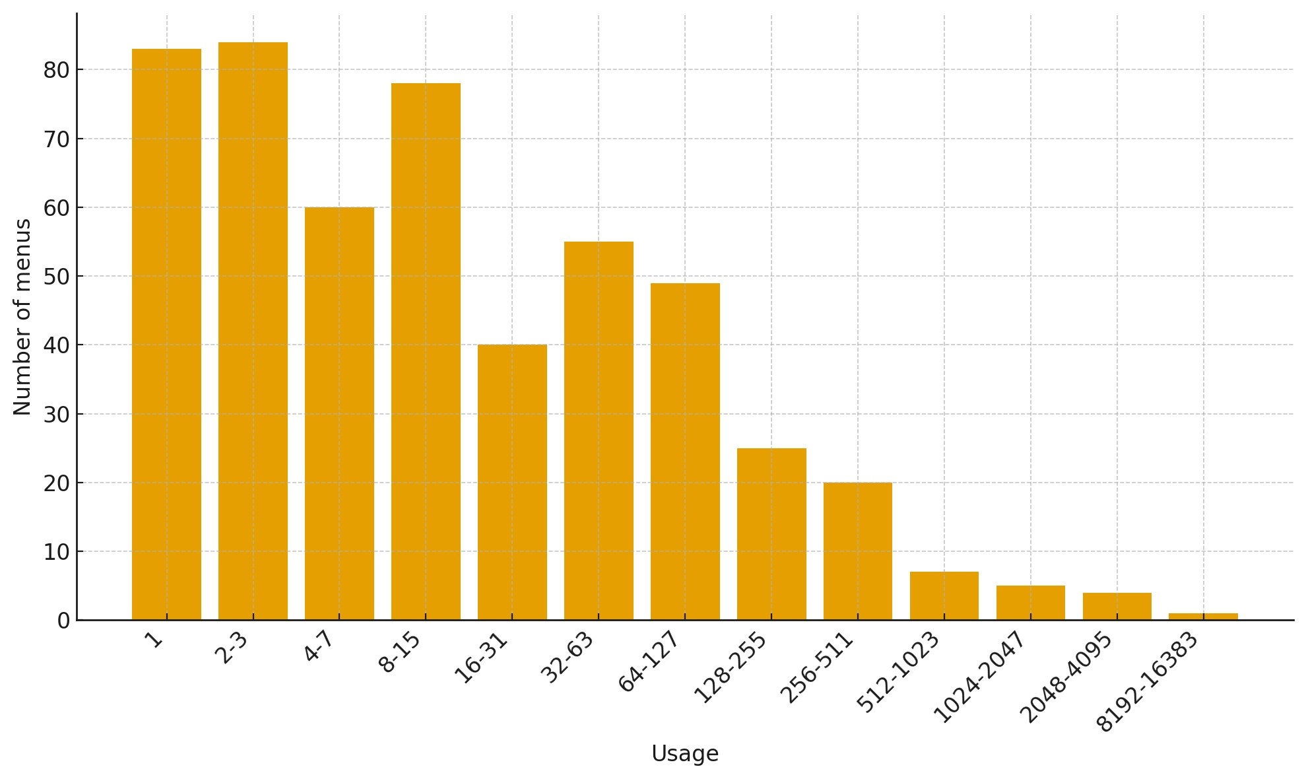

***Figure 4.3.1.1****: Menu Usage.*

* **Long tail:** 299 menus (59.3%) were used ≤15 times.
* **Core workhorses:** 62 menus (12.3%) were used ≥128 times and account for ~83.5% of selections.
* **Critical few:** 10 menus (2.0%) were used ≥1,024 times.

**Data-driven Recommendations (usage):** - Remove or hide **never-chosen** menus (**204**). - Prioritize **workhorse** menus (**62**) for fast access and UX polish. - Monitor **very high-usage** menus (**10**) for performance and content drift.

**How many options these 504 chosen nested menus present:**

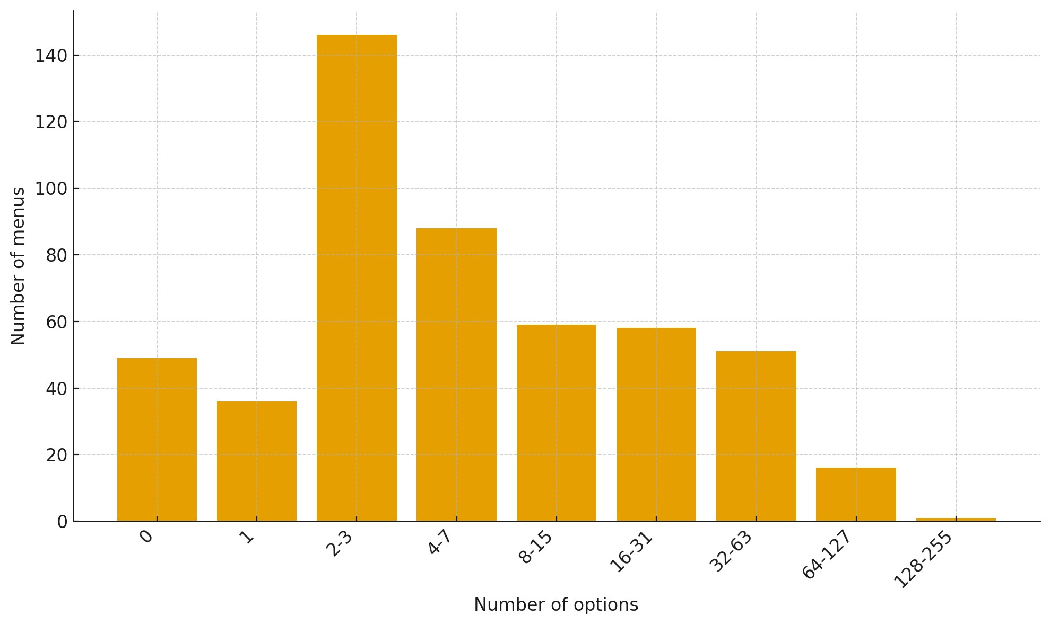

***Figure 4.3.1.2****: Menu References.*

* **Few options dominate:** 378 menus (75.0%) have ≤15 options.
* **Broad menus exist:** 68 menus (13.5%) have ≥32 options.
* **Very broad menus are rare:** 17 menus (3.4%) have ≥64 options; only 1 (0.2%) has ≥128.

**Data-driven Recommendations:** - **Consolidate** highly granular menus: **319 menus (63.3%)** with ≤7 options are likely too specialized to justify a separate level. - **Split or tighten** very broad menus: **17 menus (3.4%)** with ≥64 options risk choice overload.



#### 4.3.2 Orders from Menus

The traffic presents **3,495** order types. Of these, **2,931** appeared as menu options, **470** appeared in Order Sets, and **94** appeared in both—so **3,025** order types appeared in menus. **1,179 (39%)** were actually chosen by clinicians, and **1,174** of those were **Quick Order** types (i.e., nearly all chosen orders were QOs).

**How often these 1,174 Quick Order types were chosen:**

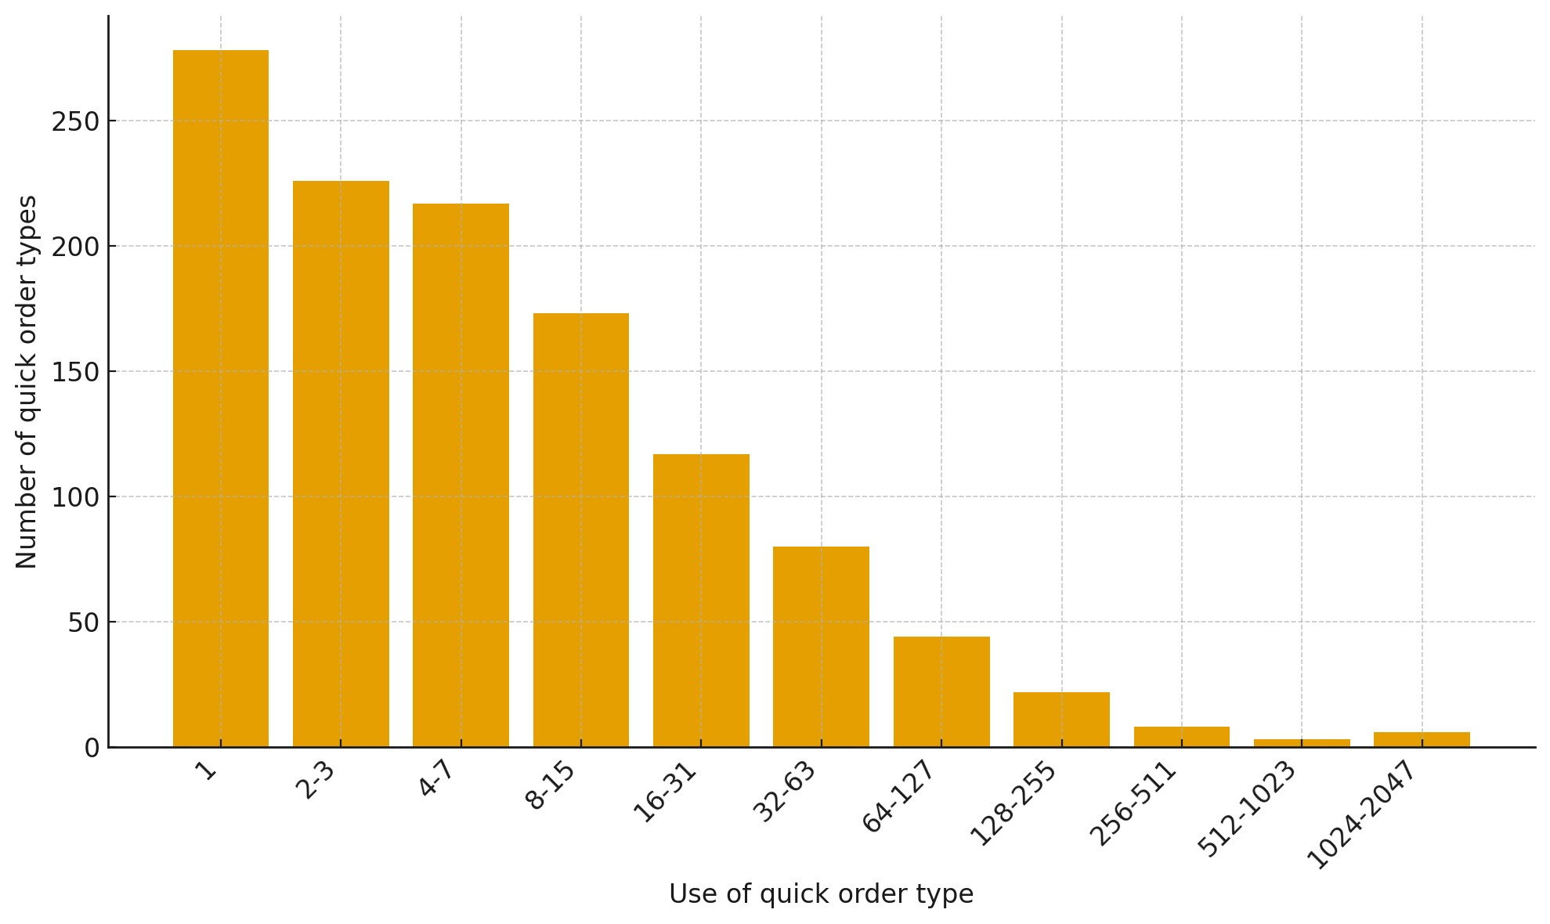

***Figure 4.3.2.1****: Quick Orders Referenced.*

* **Infrequent use dominates:** 894 QO types (76.1%) were used ≤15 times; 504 (42.9%) were used ≤3 times, including 278 (23.7%) used once.
* **Moderate usage:** 197 types (16.8%) saw 16–63 uses.
* **Heavy use is rare:** 39 types (3.3%) were used ≥128 times.

**Data-driven Recommendations:** - **Audit and prune** the long tail of rarely used QOs. - **Surface** the heavy-use QOs (e.g., pin, promote, or add to Root Menus). - **Consolidate** overlapping, low-use QOs into a smaller set of more general-purpose QOs with broader applicability



#### 4.3.3 Order Sets from Menus

**481** Order Sets were presented in menus; only **178 (37%)** were chosen.

**How often the 178 chosen Order Sets were used:**

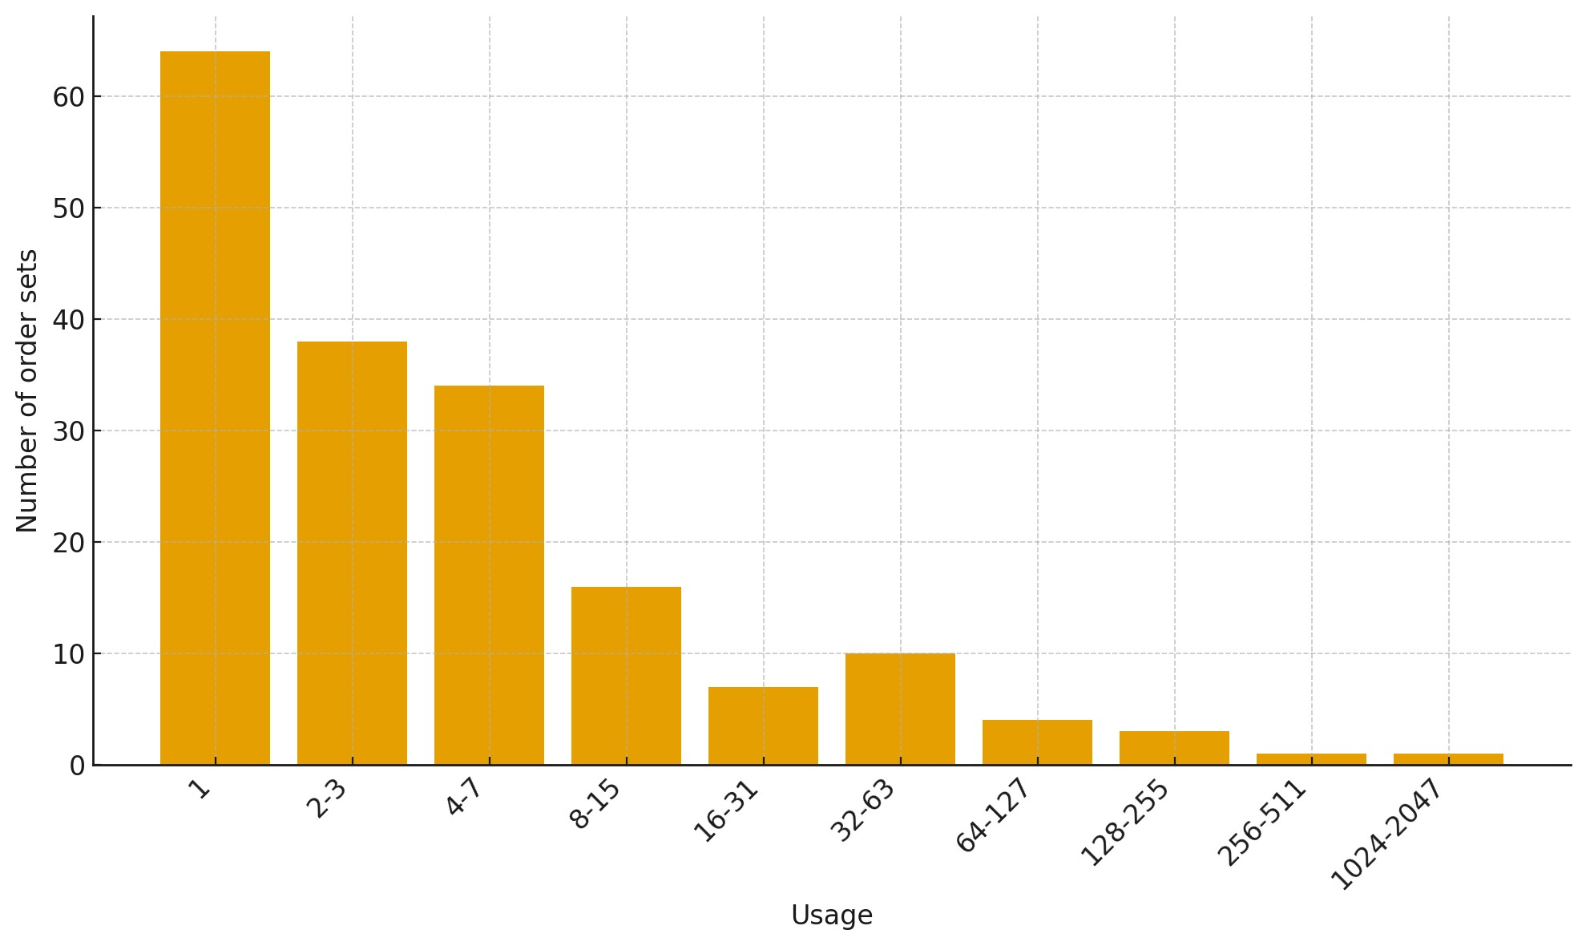

***Figure 4.3.3.1****: Order Set Usage.*

* **Mostly rare:** 152 sets (85.4%) were used ≤15 times.
* **Core few:** 5 sets (2.8%) were used ≥128 times and account for ~61.4% of selections (approx.).
* **Critical single:** 1 set (0.6%) was used ≥1,024 times.

**How large the chosen Order Sets are:**

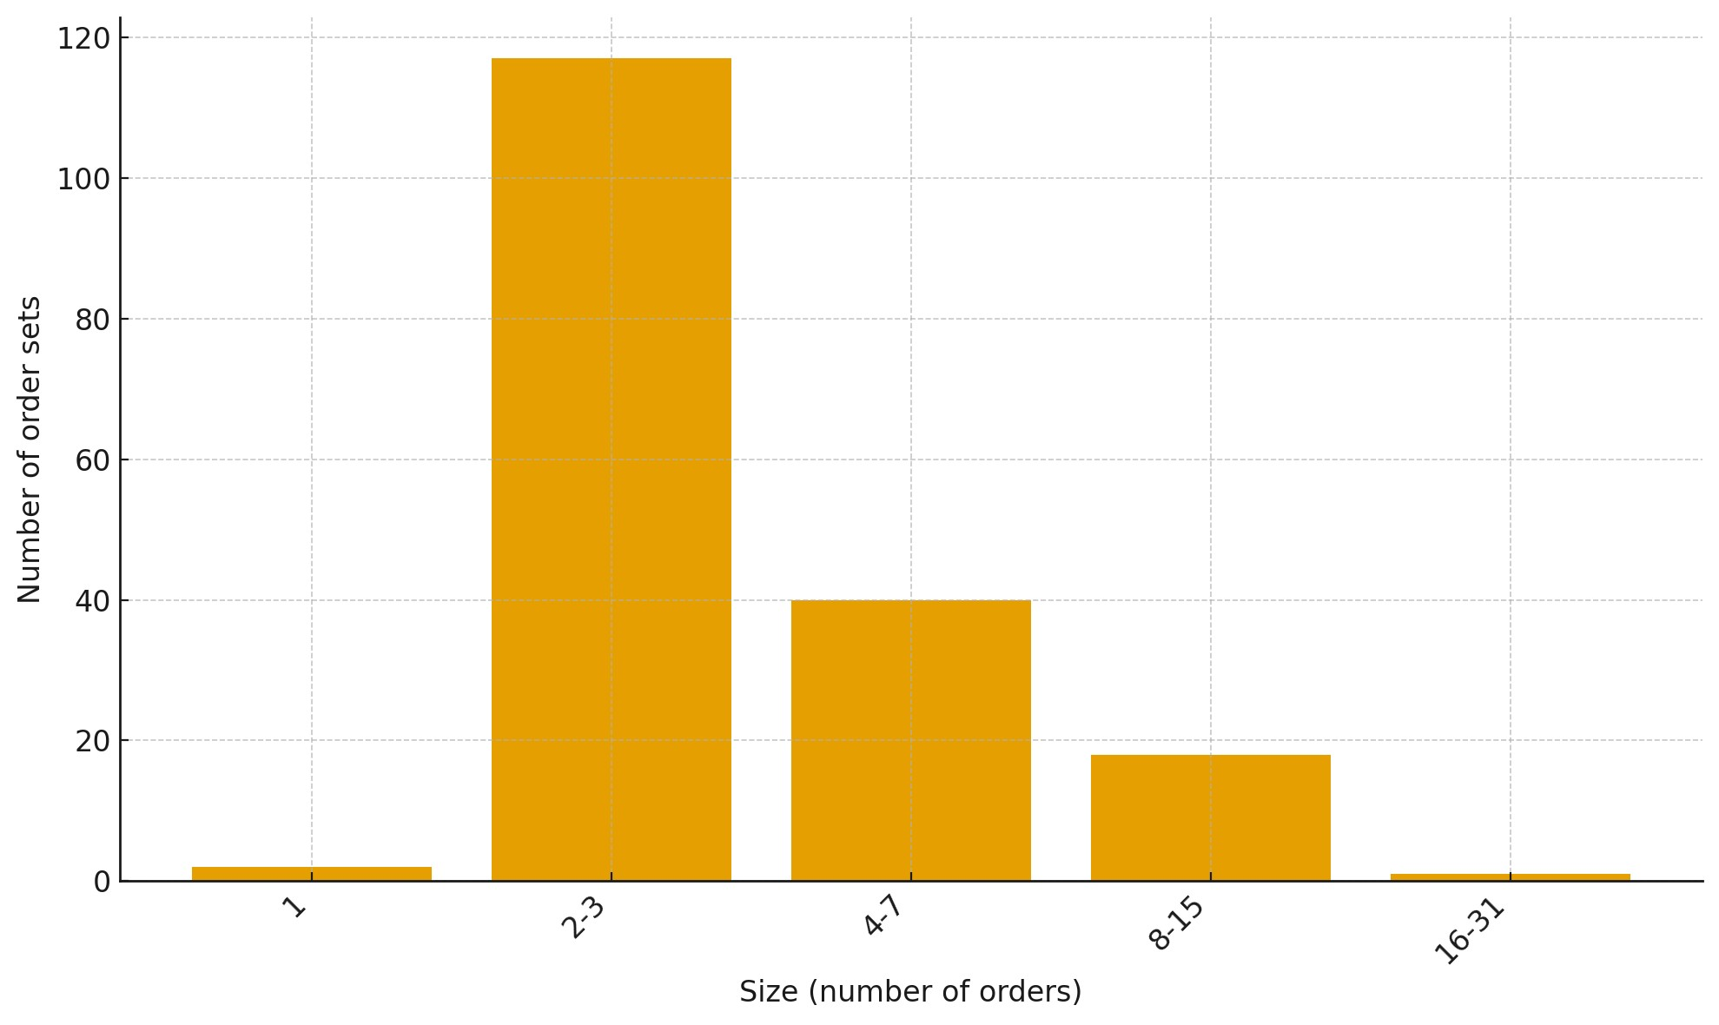

***Figure 4.3.3.2****: Order Set Members.*

* **Very small dominates:** 119 sets (66.9%) have ≤3 orders.
* **Small/moderate:** 159 sets (89.3%) have ≤7 orders.
* **Larger sets are uncommon:** 18 sets (10.1%) have 8–15 orders; 1 set (0.6%) has 16– 31 orders.

**Data-driven Recommendations:** - **Remove** Order Sets that saw no use (in the analysis window)

# 5. Recommendations

To improve ordering efficiency, VA should enhance CPRS/VistA in two complementary ways: 1) **Continuously measure real-world use** (Order Menus, Quick Orders, Order Sets, dialogs). 2) **Continuously tune the order configuration** based on that use.

We propose a lightweight monitoring mechanism and an **Adaptive Order Optimizer (AOO)**—a usage-driven service that learns from clinician behavior and safely adjusts **what appears, where, and in what sequence** across Order Menus, Quick Orders, and Order Sets.



##### 5.1 Monitoring & Key Performance Indicators

VA should establish a site-level **monitoring mechanism** that continuously summarizes how clinicians navigate menus and create orders. The objective is not to capture clinical content, but to compute a small set of **Key Performance Indicators (KPIs)** that show whether navigation and ordering are efficient, safe, and aligned with real-world use. **Core KPIs to monitor**

* **Selection rate** — Of the items shown (menus, Quick Orders, Order Sets, dialogs), how often is an item chosen? *Purpose:* validates what deserves screen real estate.
* **Time-to-order (p50/p90)** — Elapsed time from first entry into Orders to order placement. *Purpose:* primary speed signal; report medians and tail latency.
* **Clicks-to-order** — Count of navigation clicks plus essential dialog actions to place an order. *Purpose:* reveals unnecessary depth and extra steps.
* **Abandon rate** — Sessions that start but end without placing an order. *Purpose:* flags dead ends and confusing paths.
* **Share via Quick Orders** — Percent of all orders placed through Quick Orders. *Purpose:* indicates how much prompt entry is being avoided.
* **Default-override rate (by field/QO)** — How often clinicians change Quick Order defaults. *Purpose:* identifies bad defaults and candidates for QO tuning.
* **Dialog search reliance** — Fraction of dialog opens that require in-dialog search. *Purpose:* high reliance suggests missing QOs or weak menu design.
* **Menu breadth & depth** — Options per menu and levels to action (distribution). *Purpose:* balances cognitive load (mega menus) against drill-down (too many levels).
* **Never-used inventory** — Menus/QOs/Order Sets with zero selections over a rolling window. *Purpose:* immediate prune/disable candidates (with archive/restore).
* **QO coverage of top workflows** — For the highest-volume workflows, whether at least one well-tuned QO exists. *Purpose:* ensures Quick Orders where they pay off most.
* **Impact of changes (pre/post)** — Change in time/clicks/selection after a reconfiguration. *Purpose:* verifies that menu edits improve outcomes.



### 5.2 Adaptive Order Optimizer (AOO)

VA should implement an **Adaptive Order Optimizer (AOO)** that continuously ingests the usage measures described above and keeps CPRS/VistA ordering aligned with real-world practice. The AOO would tune **Order Menus**, **Quick Orders**, and **Order Sets** by: **promoting** high-use items to shallower levels; **demoting or hiding** low-use items; **merging** tiny submenus; **splitting** oversized “mega menus”; **deduplicating/retitling** overlapping Quick Orders; **refactoring** repeated explicit workflows into targeted QOs; and **retiring** never-selected menus, QOs, and Order Sets. Adjustments should be **context-aware** (location, role, inpatient vs. outpatient) and **time-weighted** so seasonal shifts are reflected without freezing past patterns.

VA should implement an **Adaptive Order Optimizer (AOO)** that continuously ingests the usage measures described above and keeps CPRS/VistA ordering aligned with real-world practice. The AOO would tune **Order Menus**, **Quick Orders**, and **Order Sets** by:

* **Promoting** high-use items to shallower levels
* **Demoting or hiding** low-use items
* **Merging** tiny submenus
* **Splitting** oversized “mega menus”
* **Deduplicating/retitling** overlapping Quick Orders
* **Refactoring** repeated explicit workflows into targeted QOs
* **Retiring** never-selected menus, QOs, and Order Sets

Adjustments should be **context-aware** (location, role, inpatient vs. outpatient) and **timeweighted** so seasonal shifts are reflected without freezing past patterns.